Name:Maryam Osman Elmi ID:C6240248 Class : Cns241
Linux Assignment

Chapter One:Introduction to linux
1.whoami: Displays The current username
Explanation :This command tells you which user is currently using the linux system
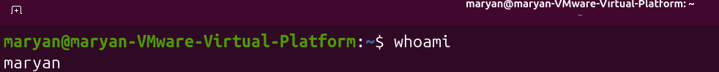
Pwd: Displays the current working directory
Explanation:displays the full path of the directory where you are currently working
Uname -r:
Explanation :Displays the linux kernel release information
Cat /etc/os-release: Displays linux distribution information
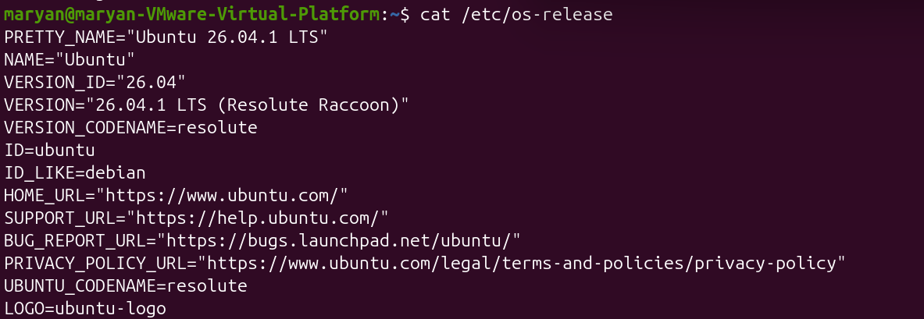
ls: Lists files and directories
Cd: Changes the current directory

Chapter two : LINUX SYSTEM ARCHITECTURE ,COMMAND LINE AND FILE MANAGEMENET
- Basic linux commands
Cd ~: Moves to the home directory

cd .. : Moves one directory up
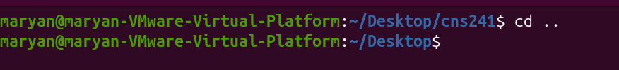
cd . : Refers to the current directory

cd - : Refers to the previos directory

ls / : Lists the contents of the root directory
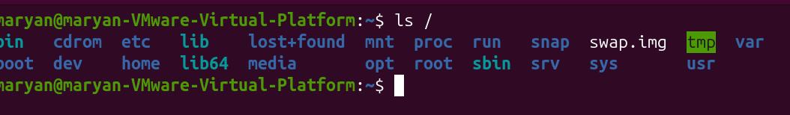
ls /home: Lists the content of the home directory
ls -a: Shows all files, including hidden files
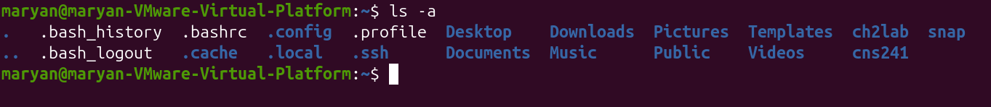
ls -l: Displays files in long format
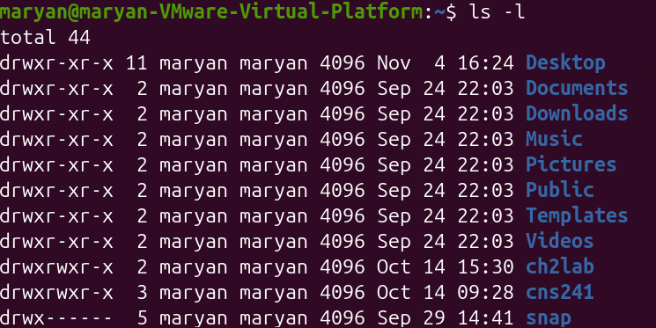
ls -h: Displays file sizes in human-readable format
ls -lh: Shows detailed information
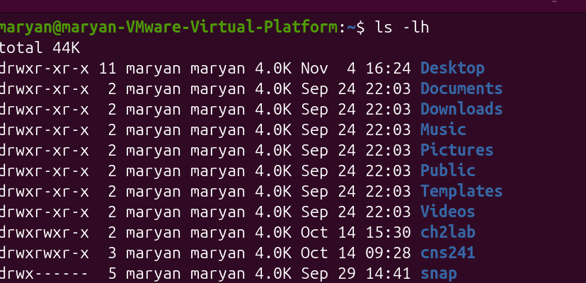
ls -lah: Shows all files in detailed, readable format
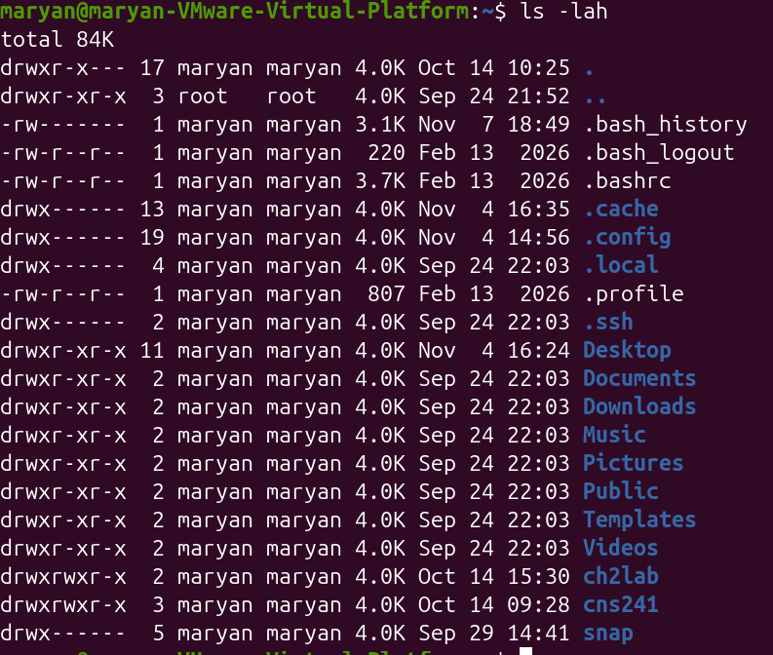

2.Terminal and Bash commands
echo $SHELL: Displays the current shell
history: Displays previously executed commands
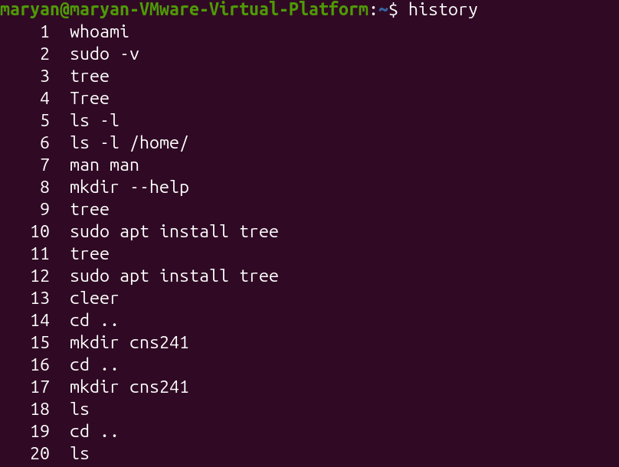
ctrl + R: Searches command history
Tab: Completes a command or filename
ctrl + Alt + T: Opens terminal in ubuntu
3:Getting help
man ls: opens the manual page for ls
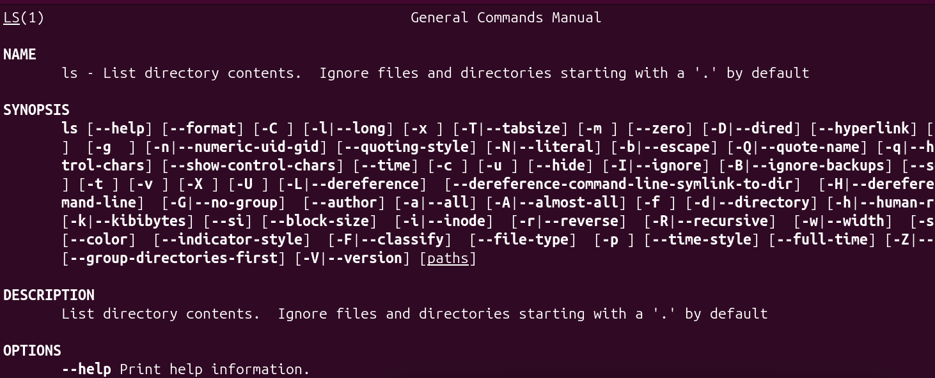
help cd: Displayes help for the bash cd command
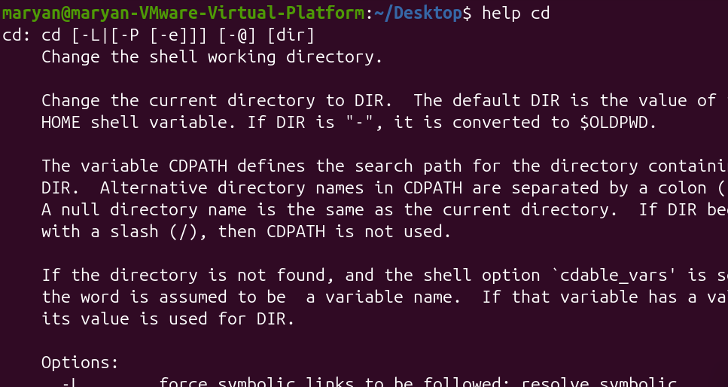
mkdir --help: Displays help for mkdir
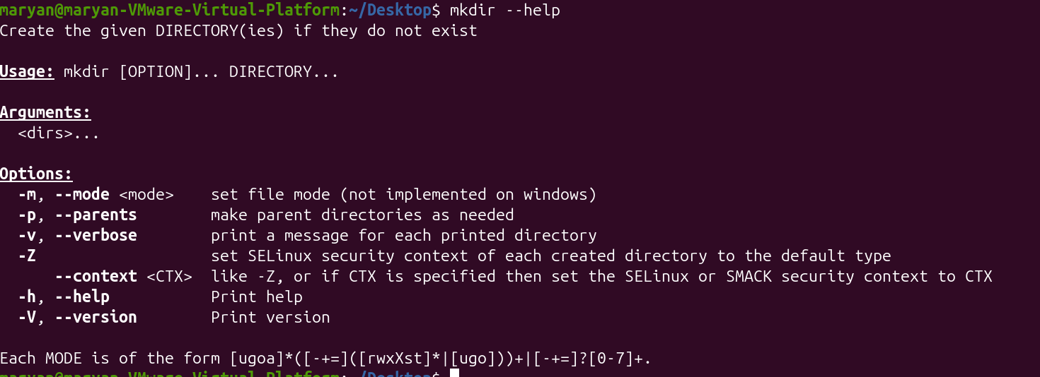
info commands: opens the information manual
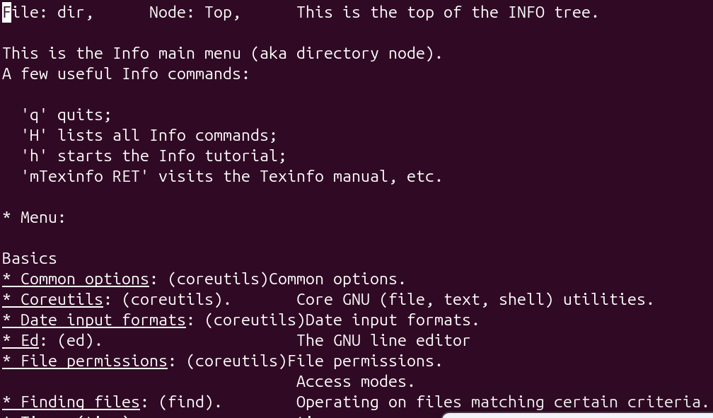
4:creating files and directories
touch notes.txt: creates an empty file
touch file1.txt file2.txt: creates two empty files
mkdir week3: creates a directory named week3
mkdir -p projects/linux: creates nested directories
mkdir -p ~/ch2lab/notes: creates the notes directory and its parent directories
mkdir ~/ch2lab/backup: creates a backup directory
rmdir week3: removes an empty directories
rmdir scratch: removes an empty directory named projects

5:copying and moving files
cp notes.txt new.txt: copies a file
cp notes.txt backup/: copies a file into another directory
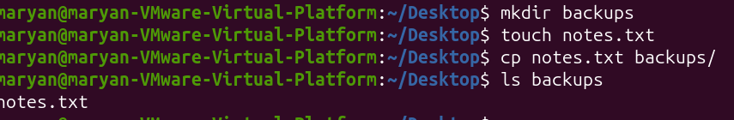
cp -r projects projects-copy: copies a directory recursively

mv notes.txt old.txt: renames a file
mv draft.txt final.txt: changes the filename
mv final.txt ~/Documents/: moves a file to documents
6.removing files and directories
rm -i notes.txt: asks for confirmation before removing a file
rm notes.txt: removes a file
rm -I file: interactively removes a file
rm -r DIR: removes a directory and its contents
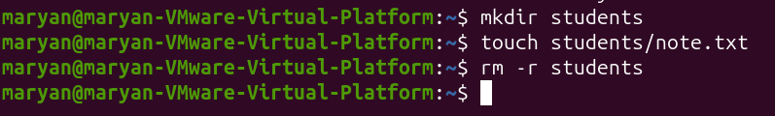
rm -rf DIR: forcefully removes a directory and its contents
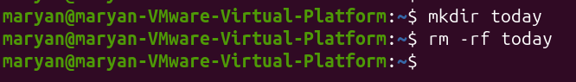
rmdir DIR: removes an empty directory
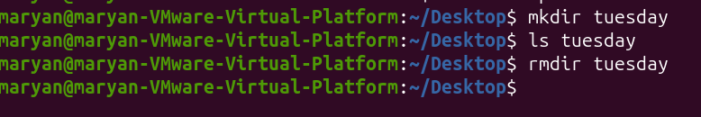
7.variables and path
echo $HOME: Displays the home directory path

echo $USER: Displays the current username
echo $PATH: Displays the path environment variables
COURSE=linux: creates a variables named COURSE
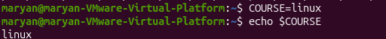
echo $COURSE: Displays the course variable’s value
ls /usr/bin/ls: Checks the location of the ls command
ls /usr/bin/mkdir: checks the location of the mkdir command
ls -a ~: lists all files in the home directory
8.quoting and escaping
echo Hello $USER: Dispays hello and the username
echo “hello $USER”: double quotes allow variable expansion
echo ‘Hello $USER: single quote prevents variable expansion

CHAPTER 3: TEXT PROCESSING, SEARCHING, ARCHIVING AND EDITORS
3.1 Viewing and Searching Files
1.cat
Function: Displays the contents of a file.
Explanation: The cat command is used to read and display the information stored inside a text file directly in the terminal. It can also display multiple files together. It is useful when you want to see the contents of a small file without opening a text editor.
Example :
cat names.txt: This displays everything written inside names.txt.
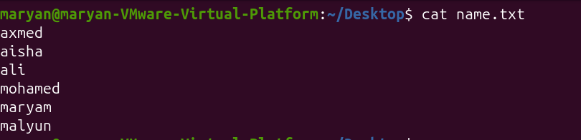
2.cat -n
Function: Displays file contents with line numbers.
Explanation: This command works like the normal cat command, but it adds a number to every line. It is useful when you want to identify a particular line in a file or refer to specific lines.
Example:
cat -n names.txt: This displays the contents of names.txt and numbers each line.
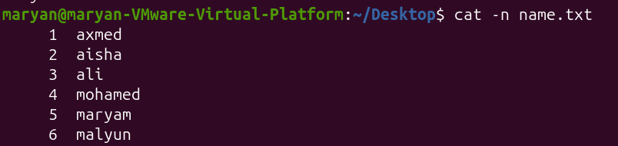
3.less
Function: Reads long files page by page.
Explanation: The less command allows you to read a large file without displaying everything at once. You can move forward and backward through the file. It is useful when working with large text files or log files.
Example:
less notes.txt

4.more
Function: Displays file contents one screen at a time.
Explanation: The more command is used to read long files in separate screens. Instead of displaying the entire file at once, it allows you to move forward through the information.
Example:
more notes.txt
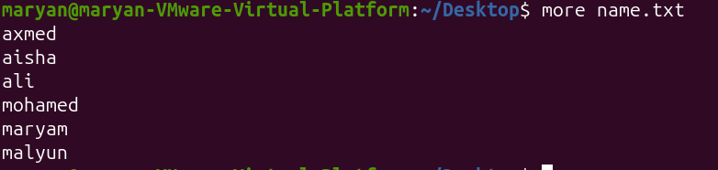
5.head
Function: Displays the first 10 lines of a file.
Explanation: The head command is used when you only need to see the beginning of a file. By default, it displays the first ten lines. You can also specify the number of lines you want to display.
Example:
head names.txt
head -n 2 names.txt
The first command displays the first ten lines, while the second displays only the first two lines.
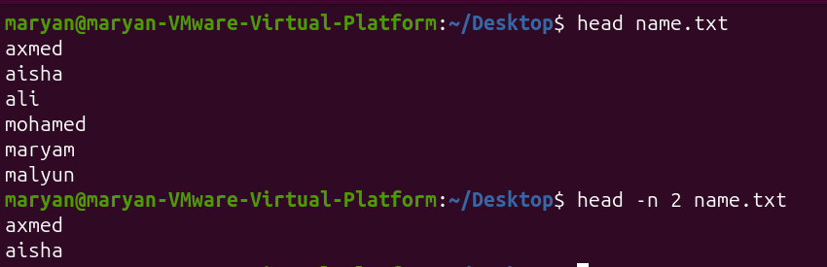
6. tail
Function: Displays the last 10 lines of a file.
Explanation: The tail command works opposite to the head command. It displays information from the end of a file. It is useful when you want to check the latest entries in a log file.
Example:
tail names.txt
tail -n 2 names.txt
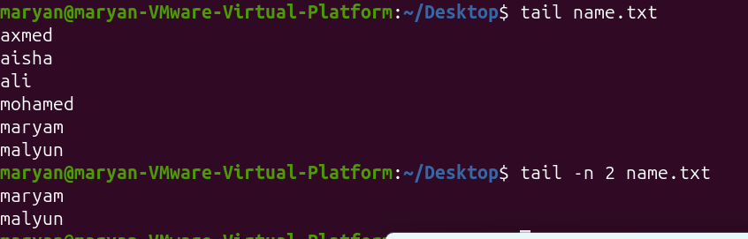
7.tail -f
Function: Monitors a file continuously.
Explanation: This command displays the last lines of a file and continues watching it for new information. When new content is added to the file, it appears automatically in the terminal. It is commonly useful for monitoring log files.
Example:
tail -f name.txt
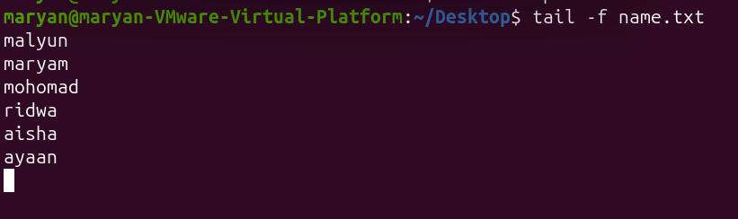
8.file
Function: Identifies the type of a file.
Explanation: The file command checks a file and tells you what type of content it contains. It helps you understand whether a file is a text file, image, executable or another file type.
Example:
file names.txt
9.stat
Function: Displays detailed file information.
Explanation: The stat command provides detailed information about a file, including its size, permissions, ownership, inode number and timestamps. It is useful when you need more information than the normal file listing provides.
Example:
stat names.txt
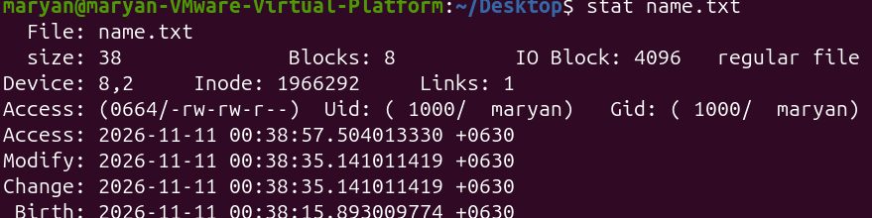
10.ls -l
Function: Displays files and directories in long format.
Explanation: This command lists files with additional information rather than showing only their names. It displays permissions, number of links, owner, group, file size and modification date.
Example:
ls -l
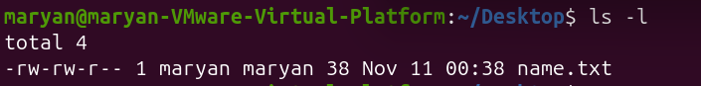
11.which
Function: Finds the location of an executable command.
Explanation: The which command searches the directories listed in the system's PATH and shows the location of an executable program. It helps you know where a command is stored.
Example:
which ls
12.type
Function: Identifies the type of a command.
Explanation: The type command tells you how the shell interprets a command. It can identify whether a command is a shell built-in, alias, function or external executable.
Example:
type cd
command -v
Function: Shows how a command is resolved by the shell.
Explanation: This command checks whether a command is available and displays how the shell identifies it. It can show the executable path or identify a shell built-in.
Example:
13.command -v ls
whereis
Function: Locates binary files, source files and manual pages.
Explanation: The whereis command searches for the location of a program and related files. It is useful when you want to find where a command's executable and documentation are located.
Example:
14.whereis tar
15.find
Function: Searches for files and directories.
Explanation: The find command searches for files and directories in a specified location. You can search using different conditions, such as filename, file type, size and modification time. It is useful when you do not know where a particular file is stored.
Examples:
find . -name "names.txt": Searches for a file named names.txt in the current directory and its subdirectories.
find . -name "*.log": Searches for files ending in .log.
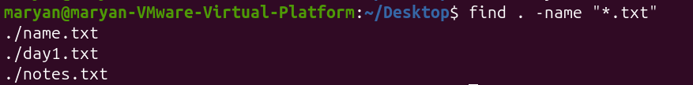
16.locate
Function: Searches for files using a database.
Explanation: The locate command helps you find files quickly by searching an existing database of file paths. Unlike find, it does not normally search the entire directory structure every time you use it. Its results depend on the database being updated.
Example:
locate names.txt
17.updatedb
Function: Updates the locate database.
Explanation: The updatedb command updates the database used by locate. It records file and directory locations so that future searches can find them. If a newly created file does not appear in a locate search, updating the database may help.
Example:
sudo updated
18.grep
Function: Searches for specific text inside files.
Explanation: The grep command searches a file for a particular word, phrase or pattern. It displays the lines that contain the matching text. It is useful when working with large files because you do not need to read the entire file to find specific information.
Example:
grep "malyun" names.txt
19.grep -n
Function: Displays matching lines with line numbers.
Explanation: This option works like normal grep, but it also shows the line number where the matching text appears. It makes it easier to locate the information inside the original file.
Example:
grep -n "ayaan" app.log
20.grep -i
Function: Searches without considering uppercase or lowercase letters.
Explanation: Normally, grep distinguishes between uppercase and lowercase letters. The -i option ignores this difference. For example, searching for error can also match ERROR or Error.
Example:
grep -i "MARYAM" name.txt
21.grep -v
Function: Displays lines that do not match a pattern.
Explanation: The -v option reverses the normal search result. Instead of displaying lines containing the selected word, it displays lines that do not contain that word.
Example:
grep -v "malyun" name.txt
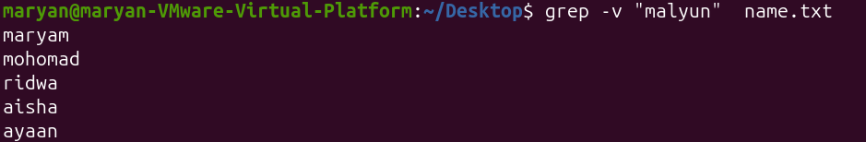
22.grep -r
Function: Searches recursively inside directories.
Explanation: The -r option allows grep to search through files inside a directory and its subdirectories. It is useful when you want to find specific text in an entire project rather than searching one file at a time.
Example:
grep -r "TODO" project/

23.grep -rn
Function: Searches recursively and displays line numbers.
Explanation: This command combines recursive searching with line numbering. It searches through files in a directory and shows both the matching text and the line number where it was found.
Example:
grep -rn "TODO" project/

24.grep -in
Function: Searches without case sensitivity and displays line numbers.
Explanation: This command combines two options. The -i option ignores uppercase and lowercase differences, while -n displays the line number. It is useful when searching for a word whose capitalization may be different.
Example:
grep -in "AYAAN" name.txt
3.2 Redirection, Pipes and Text Processing
1. >
Function: Redirects output into a file and overwrites existing content.
Explanation: The greater-than symbol sends the output of a command into a file instead of displaying it on the terminal. If the file already contains information, its previous content is replaced.
Example:
echo "Hello" > day1.txt: Creates file.txt and stores Hello inside it. If the file already exists, its previous content is overwritten.
2.>>
Function: Appends output to the end of a file.
Explanation: This operator sends command output into a file without deleting its existing content. New information is added after the previous content.
Example:
echo "Welcome" >> file.txt: Adds Welcome at the end of thefile.
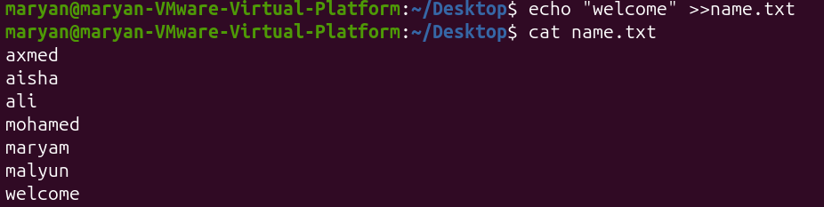
3.2>
Function: Redirects error messages into a file.
Explanation: Linux uses file descriptor 2 for standard error. This operator sends error messages to a specified file instead of displaying them on the terminal. It is useful when you want to save error information.
Example:
ls missing.txt 2> error.txt
4.<
Function: Takes input from a file.
Explanation: The less-than symbol redirects the contents of a file into a command as its input. This allows a command to read information directly from a file rather than receiving it from the keyboard.
Example:
wc -l < names.txt
5. | (Pipe)
Function: Sends the output of one command as input to another command.
Explanation: A pipe connects two or more Linux commands. The first command performs an operation, and its output is passed directly to the next command. This makes it possible to perform several operations in one command line.
Example:
cat names.txt | wc -l: The first command displays the file contents, and the second counts the lines.

6.;
Function: Executes multiple commands sequentially.
Explanation: The semicolon allows you to write more than one command on the same line. Linux executes the commands one after another, regardless of whether the previous command succeeds or fails.
Example:
mkdir test ; echo "Done"
7.&&
Function: Executes the next command only if the previous command succeeds.
Explanation: The && operator is used when the second command should run only after the first command has completed successfully. It helps control the order of command execution.
Example:
mkdir test && echo "Success": The message appears only if the directory is created successfully.
8.||
Function: Executes the next command if the previous command fails.
Explanation: The || operator provides an alternative action when a command is unsuccessful. If the first command fails, Linux executes the command after ||.
Example:
test -f missing.txt || echo "Not found"
9.$?
Function: Displays the exit status of the last command.
Explanation: Linux uses exit status codes to indicate whether a command was successful. A value of 0 normally means success, while a non-zero value indicates an error or unsuccessful result.
Example:
ls
echo $?
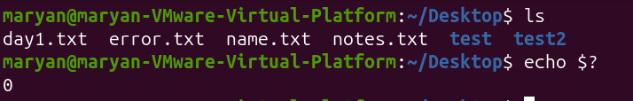
10.sort
Function: Arranges lines of text in sorted order.
Explanation: The sort command organizes lines in a file. By default, it sorts lines alphabetically according to their characters. It is useful when arranging names, words or other text information.
Example:
sort names.txt
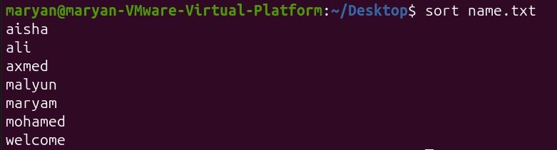
11.sort -n
Function: Sorts numbers numerically.
Explanation: The -n option tells Linux to treat the values as numbers rather than sorting them as ordinary text. It is useful when arranging numerical information from smallest to largest.
Example:
sort -n scores.txt
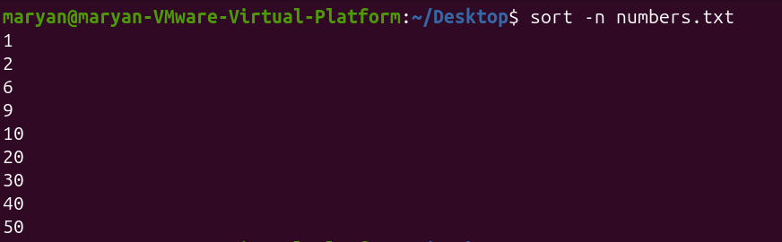
12.sort -r
Function: Sorts in reverse order.
Explanation: The -r option reverses the normal sorting order. Instead of displaying results in ascending alphabetical order, it displays them in descending order.
Example:
sort -r names.txt
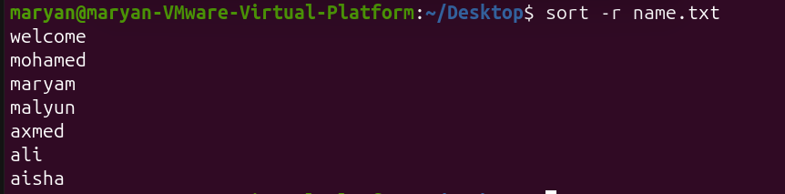
13.sort -rn
Function: Sorts numbers in reverse numerical order.
Explanation: This command combines numerical sorting and reverse sorting. It arranges numbers from the largest to the smallest.
Example:
sort -rn scores.txt
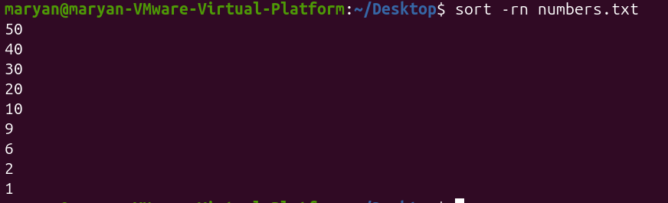
14.uniq
Function: Removes repeated adjacent lines.
Explanation: The uniq command identifies and removes duplicate lines that appear next to each other in the input. It is often combined with sort because sorting places identical lines together.
Example:
sort name.txt | uniq
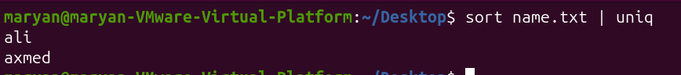
15.uniq -c
Function: Counts repeated adjacent lines.
Explanation: The -c option displays each unique line together with the number of times it appears consecutively in the input. It is useful for counting repeated names or values.
Example:
sort name.txt | uniq -c
16.uniq -d
Function: Displays only duplicate adjacent lines.
Explanation: This option shows only lines that appear more than once next to each other. It hides lines that appear only once.
Example:
sort name.txt | uniq -d
17.cut
Function: Extracts specific characters or fields from lines.
Explanation: The cut command selects particular parts of text. You can extract information using character positions or field numbers. When working with structured text, you can specify a delimiter to separate the fields.
Example:
cut -d: -f1 users.txt: Uses the colon as a delimiter and displays the first field.
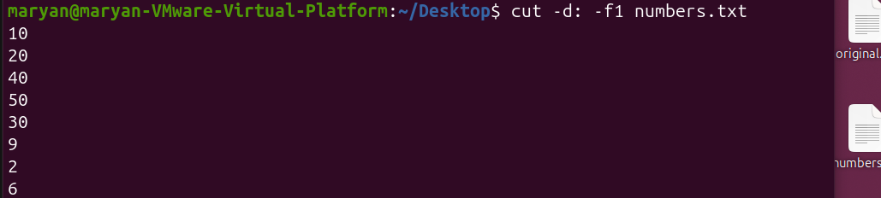
cut -c 1-4 names.txt: Displays characters from position 1 to position 4.
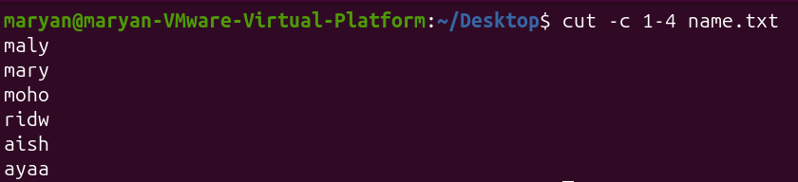
18.paste
Function: Combines lines from multiple files.
Explanation: The paste command joins corresponding lines from different files. By default, it separates the combined information using a tab. It is useful when you have two files containing related information that you want to display together.
Example:
paste numbers.txt name.txt
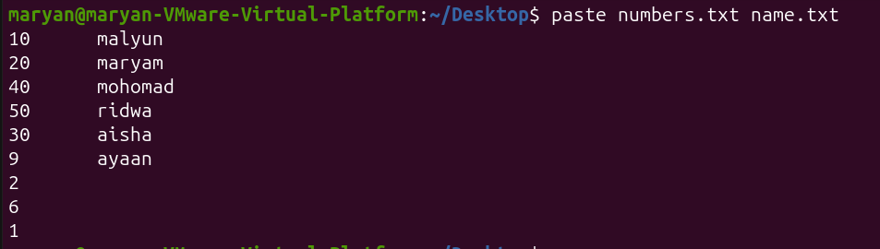
19.paste -d
Function: Combines lines using a specified delimiter.
Explanation: The -d option allows you to choose which character separates the combined information. For example, you can use a comma instead of the default tab.
Example:
paste -d, names.txt scores.txt
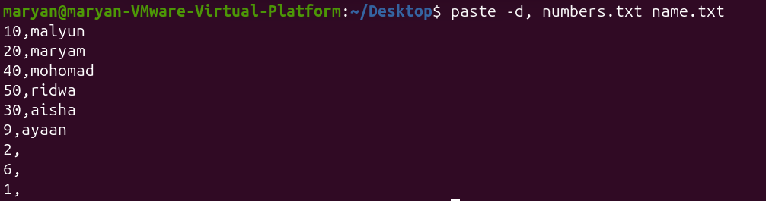
20.paste -s
Function: Combines all lines of each file serially.
Explanation: The -s option changes the normal behavior of paste. Instead of combining corresponding lines from different files, it combines lines from each file into one line.
Example:
paste -s -d, names.txt
21.wc
Function: Counts lines, words and bytes.
Explanation: The wc command provides information about the amount of text in a file. Without options, it displays the number of lines, words and bytes. It is useful when measuring the size of text files.
Example:
wc numbers.txt
22.wc -l
Function: Counts the number of lines.
Explanation: The -l option tells wc to count only the lines in a file. It is useful when you want to know how many lines of information a document contains.
Example:
wc -l numbers.txt
23.wc -w
Function: Counts the number of words.
Explanation: This option counts the words contained in a file. It is useful when checking the word count of a document or text file.
Example:
wc -w name.txt
24.wc -c
Function: Counts the number of bytes.
Explanation: The -c option displays the total number of bytes in a file. It helps you understand the amount of storage occupied by the file's contents.
Example:
wc -c numbers.txt
25.wc -m
Function: Counts the number of characters.
Explanation: The -m option counts characters rather than bytes. This distinction matters because some characters, especially Unicode characters, can use more than one byte.
Example:
wc -m name.txt
26.tr
Function: Translates or changes characters.
Explanation: The tr command reads input and replaces one set of characters with another. It is commonly used to change lowercase letters into uppercase letters or to replace particular characters.
Example:
tr 'a-z' 'A-Z' < names.txt
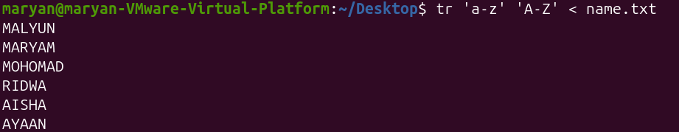
27.tr -d
Function: Deletes specified characters.
Explanation: The -d option tells tr to remove selected characters from the input. It is useful when cleaning text by removing unwanted characters.
Example:
echo "Hello123" | tr -d '123'
28.tr -s
Function: Squeezes repeated characters into one character.
Explanation: The -s option reduces repeated occurrences of a character to a single occurrence. It is useful when cleaning text that contains unnecessary repeated spaces or other characters.
Example:
echo "too many" | tr -s ' '
3.3 Archives and Compression
This section explains how to combine files into archives, compress files to reduce their size, list archive contents and extract archived files.
1.tar
Function: Creates and manages archive files.
Explanation: The tar command is used to collect multiple files and directories into a single archive. It makes it easier to organize and transfer related files together. The archive can also be compressed using different compression methods.
Example:
tar -cf backup.tar notes.txt
2. tar -cf
Function: Creates a tar archive.
Explanation: The -c option creates a new archive, while -f specifies the archive filename. This command combines the selected files into one archive without applying compression.
Example:
tar -cf backup.tar day1.txt notes.txt
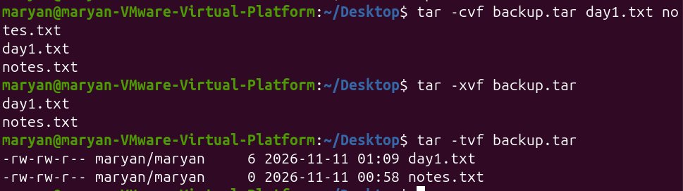
3.tar -cvf
Function: Creates an archive and displays the filenames being added.
Explanation: The -v option means verbose. It displays the names of the files while they are being added to the archive. It helps you see which files are included.
Example:
tar -cvf project.tar project/
4.tar -tf
Function: Lists the contents of a tar archive.
Explanation: This command allows you to see which files and directories are stored inside an archive without extracting them. It is useful when you want to check the archive contents first.
Example:
tar -tf backup.tar
5.tar -xf
Function: Extracts files from a tar archive.
Explanation: The -x option extracts the contents of an archive, while -f specifies the archive filename. It restores the files and directories stored inside the archive.
Example:
tar -xf project.tar
11.gzip
Function: Compresses files using gzip.
Explanation: The gzip command reduces the size of a file by compressing its contents. It normally creates a file with the .gz extension. By default, it replaces the original file with the compressed version.
Example:
gzip error.txt
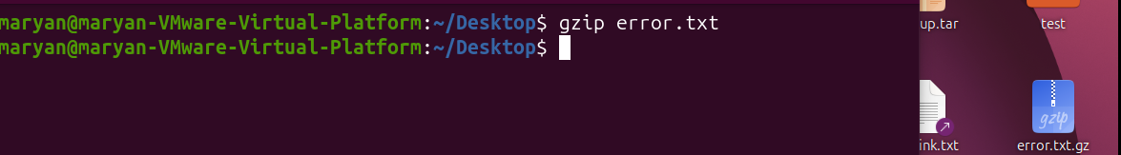
12.gzip -k
Function: Compresses a file while keeping the original.
Explanation: The -k option tells gzip to keep the original file after compression. This allows you to have both the original file and the compressed version.
Example:
gzip -k numbers.txt
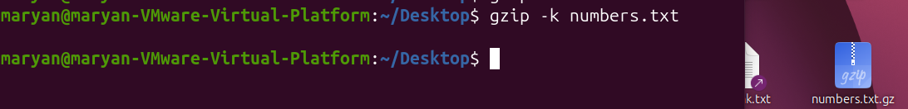
13.gzip -9
Function: Uses the highest gzip compression level.
Explanation: The -9 option requests maximum compression. It attempts to produce a smaller compressed file, although it may take more processing time than lower compression levels.
Example:
gzip -9 notes.txt
14.gunzip
Function: Decompresses gzip files.
Explanation: The gunzip command reverses gzip compression. It restores the compressed file to its original uncompressed form.
Example:
gunzip notes.txt
3.4 Text Editors: Nano and Vim
Text editors are programs used to create, open, edit and save text files in Linux. This section covers two common terminal-based text editors: Nano and Vim.
A. Nano Editor
1.nano filename
Function: Opens or creates a text file using Nano.
Explanation: Nano is a simple, beginner-friendly text editor that works inside the terminal. You can use it to write new text, modify existing information and save changes. If the specified file does not exist, Nano allows you to create it.
Example:
nano name.txt
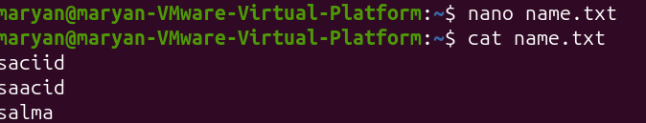
2.Ctrl + O: Function: saves the current file
Enter : Function: Confirms the filename.
Ctrl + X: Function: Exits the Nano editor.
Ctrl + W: Function: Searches for text inside a file.
Vim is a powerful terminal-based text editor. Unlike Nano, Vim uses different modes to perform different operations. Understanding these modes is important when using Vim.
1. vim filename
Function: Opens or creates a file using Vim.
Explanation: The vim command starts the Vim text editor and opens the specified file. If the file does not exist, Vim can create it when you save your work.
Example:
vim hello.txt
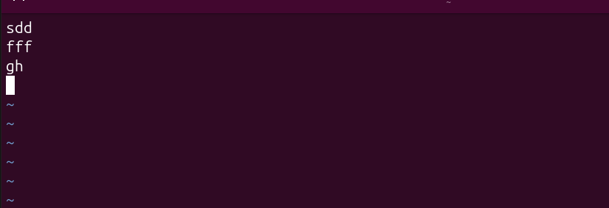
vi filename
Function: Opens a file using the Vi editor.
Explanation: The vi command starts the Vi text editor. Vi is the traditional editor on which Vim is based. It is used to open, edit and save text files.
Example:
vi hello.txt
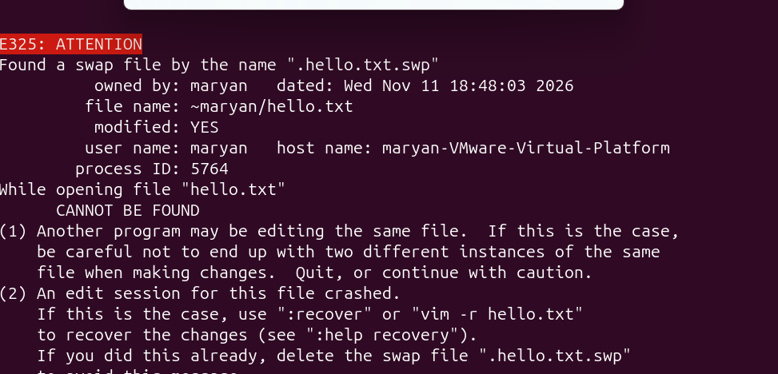
vimtutor
Function: Opens the Vim tutorial.
Explanation: The vimtutor command starts an interactive tutorial that teaches users how to operate Vim. It introduces basic editing commands, movement, saving and other useful operations.
Example:
Vimtutor
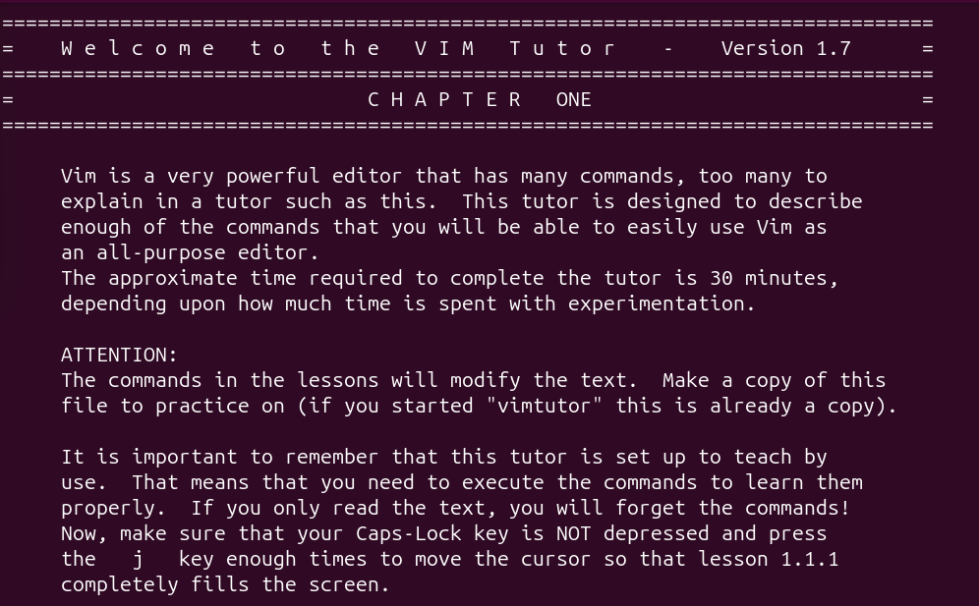
:Hard link and symbolic link
1. ln
Function: Creates a hard link.
Explanation: The ln command creates another directory entry that refers to the same file data as the original file. A hard link and the original file share the same inode number. This means both names refer to the same underlying file contents.
Example:
ln original.txt hardlink.txt: Both filenames refer to the same file data. Changes made through one name are reflected when the file is accessed through the other.
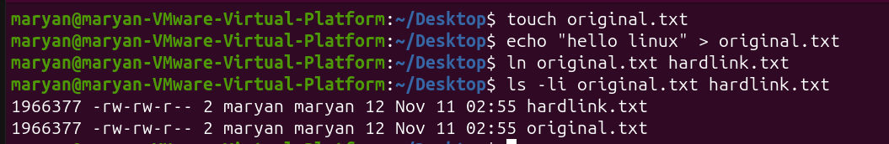
2. ln -s
Function: Creates a symbolic or soft link.
Explanation: The -s option creates a symbolic link. A symbolic link is a special file that stores the path to another file or directory. It works like a shortcut. Unlike a hard link, it has its own inode number and points to the target path.
Example:
ln -s original.txt softlink.txt
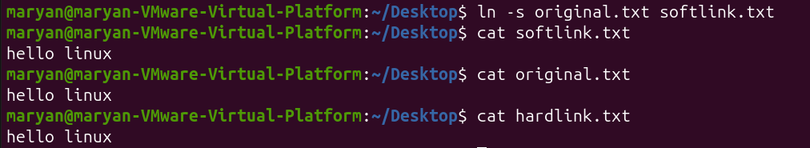
3. ls -li
Function: Displays files with their inode numbers.
Explanation: The -l option displays files in long format, while -i displays the inode number. It is useful when comparing hard links because files that are hard links to the same file share the same inode number.
Example:
ls -li original.txt hardlink.txt

CHAPTER 4 – ALL LINUX COMMANDS
4.1 Processes and Jobs
1. echo $$
Explanation
The echo command displays text or variable values in the terminal. The special variable $$ represents the Process ID (PID) of the current shell.
It helps you identify the PID of the terminal shell you are currently using.
Example:
echo $$
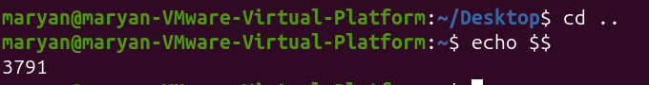
2. ps
Explanation
The ps command stands for Process Status. It displays information about processes currently running on the system.
It provides a snapshot of processes at the moment you execute the command. Unlike top, it does not continuously refresh.
Example:
ps
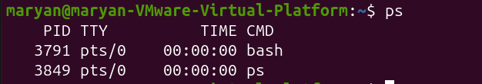
3. ps -f
Explanation:
The -f option means Full Format. It displays more detailed information about running processes, including the process owner, PID, PPID and starting time.
PPID means Parent Process ID. It identifies the process that started another process.
Example:
ps -f: This command is useful when you want to understand the relationship between parent and child processes.
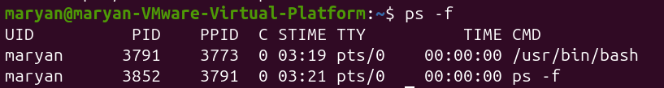
4.ps -p PID
Explanation:
The -p option allows you to display information about one specific process using its PID.
Instead of displaying multiple processes, it focuses on the process number you provide.
Example:
ps -p 1: This displays information about process number 1.
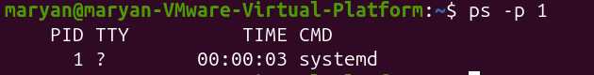
5.ps -o
Explanation:
The -o option allows you to select which columns you want to display.
This is useful when you need specific information instead of a complete process listing.
Example:
ps -o pid,ppid,comm
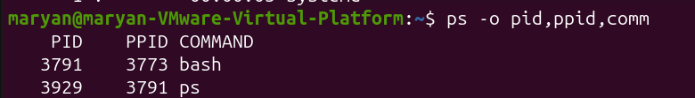
6.ps aux
Explanation:
The ps aux command displays all running processes on the entire system, including processes belonging to other users.
It also displays CPU usage, memory usage, process status and other details.
It is useful when you want to monitor all processes running on Ubuntu.
Example:
ps aux
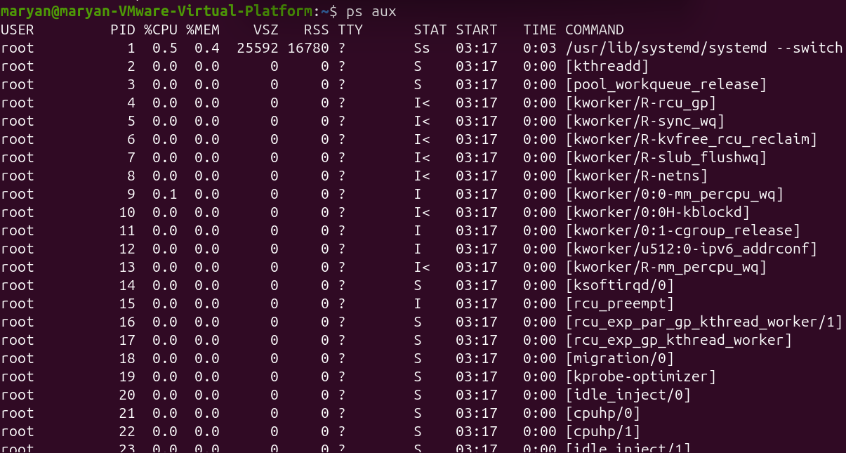
7.ps aux | less
Explanation:
This command displays all running processes but uses less to show the output page by page.
It is useful because the process list can be very long, making it difficult to read everything on one screen.
Example:
ps aux | less
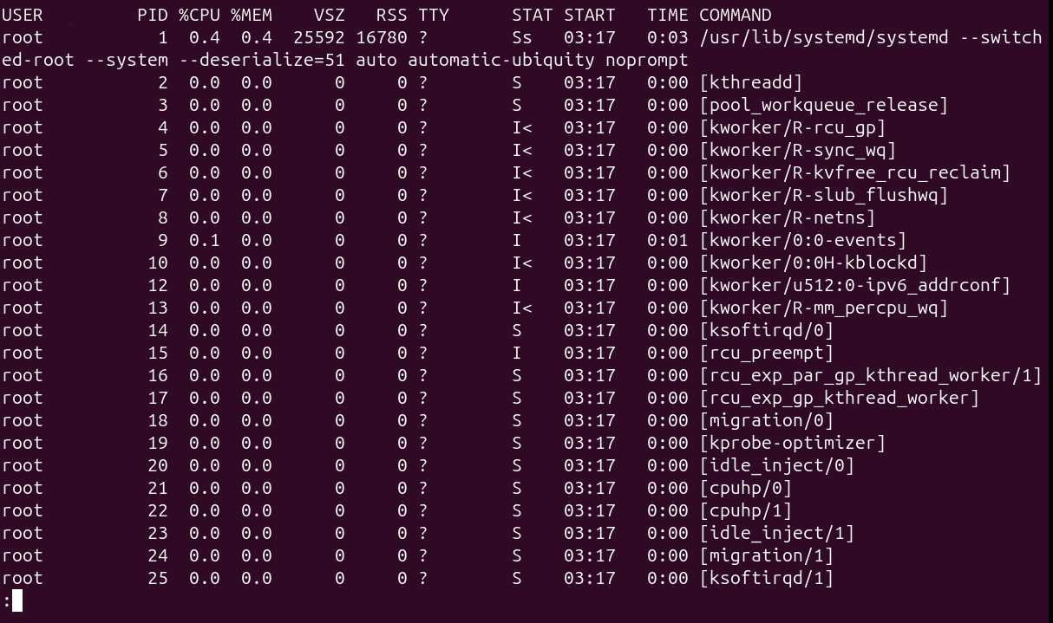

9.ps -ef
Explanation:
The ps -ef command displays every process running on the system using full-format information.
It includes PID, PPID, user, starting time and command.
It is similar to ps aux, but uses a different output format.
Example:
ps -ef : e: Displays every process. -f: Displays full information.
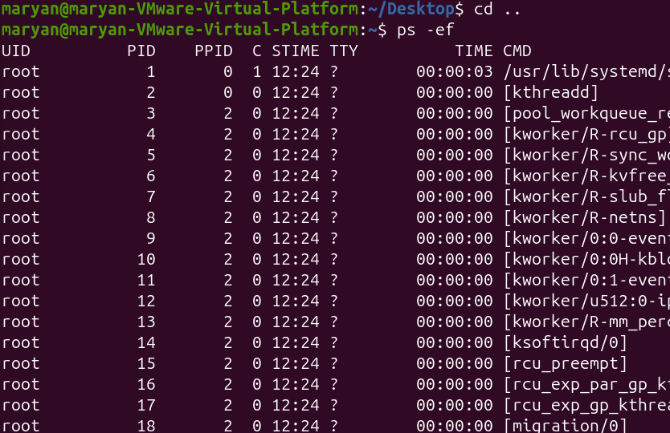
10.ps -ef | head -n 4
Explanation:
This command displays only the first four lines of the complete process list.
It is useful when you want to inspect a small part of the process list without displaying everything.
Example:
ps -ef | head -n 4
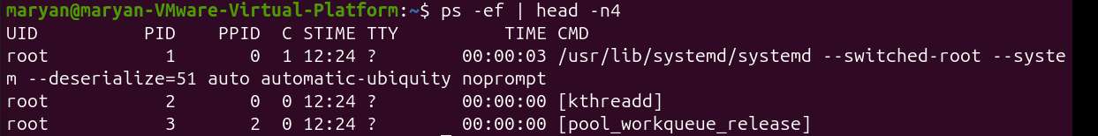
11.pstree -p
Explanation:
The pstree command displays running processes in a tree structure.
It shows the relationship between parent and child processes.
The -p option displays the PID numbers next to process names.
Example:
pstree -p $$: This displays the process tree starting from your current shell.
12.top
Explanation:
The top command provides a live view of running processes. It continuously updates the information every few seconds.
It helps administrators monitor CPU usage, RAM usage, running processes and system performance.
Example:
top
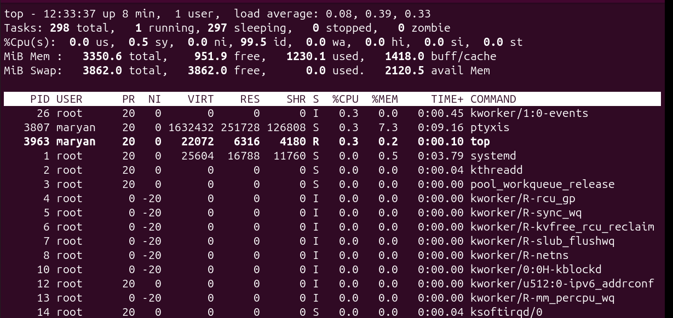
13.top -u USER
Explanation:
This command displays only the processes belonging to a particular user.
It is useful when a system has multiple users and you want to monitor the processes of one specific user.
Example:
top -u USER
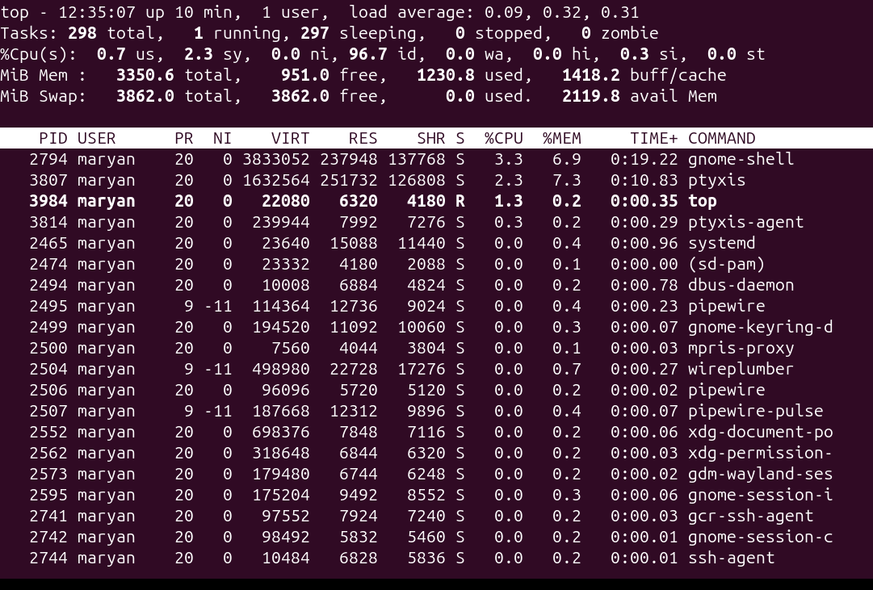
14.command -v htop
Explanation:
The command -v command checks whether a command or program is available in the system and displays its location.
It is useful for checking whether htop is installed before trying to run it.
Example:
command -v htop
15.htop
Explanation:
The htop command is an interactive process-monitoring tool similar to top.
It displays running processes using colours, provides mouse support and allows users to manage processes interactively.
Example:
htop
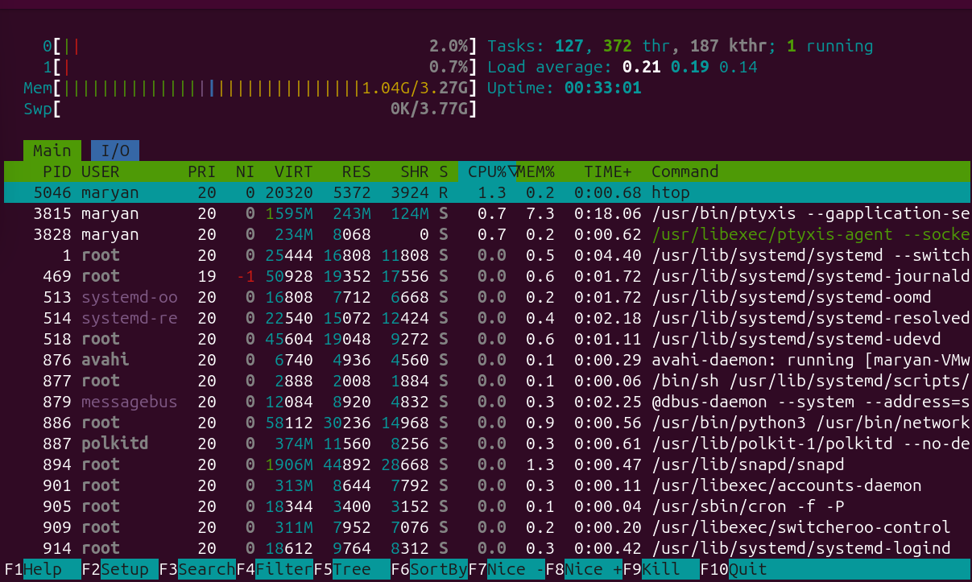
16.htop -u student
Explanation:
This command opens htop and displays only the processes belonging to the specified user.
Example:
htop -u student
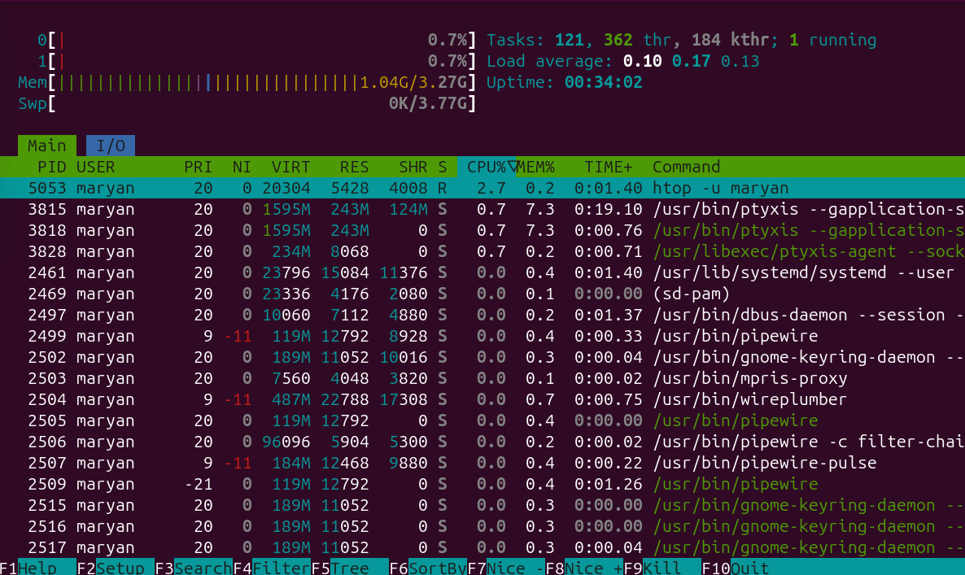
17.htop -t
Explanation:
The -t option displays processes in a tree structure.
Child processes appear underneath their parent processes.
Example:
htop -t
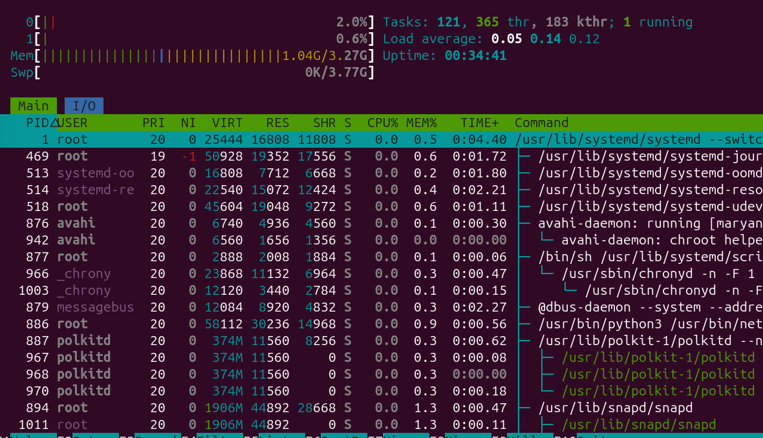
18.sleep
Explanation:
The sleep command pauses execution for a specified amount of time.
It is commonly used for testing foreground and background processes.
Example:
Sleep 30: The terminal waits for 30 seconds before returning to the prompt.
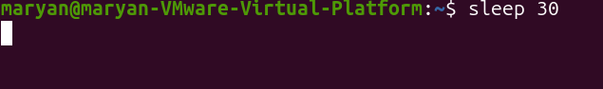
19.sleep 30 &
Explanation:
The & symbol runs a command in the background.
Instead of making the terminal wait until the process finishes, Linux returns the prompt immediately.
Example:
Sleep 30 &
20.gnome-calculator &
Explanation:
This command opens the GNOME Calculator application in the background.
The & symbol allows the terminal to remain available while the calculator is running.
Example:
gnome-calculator &
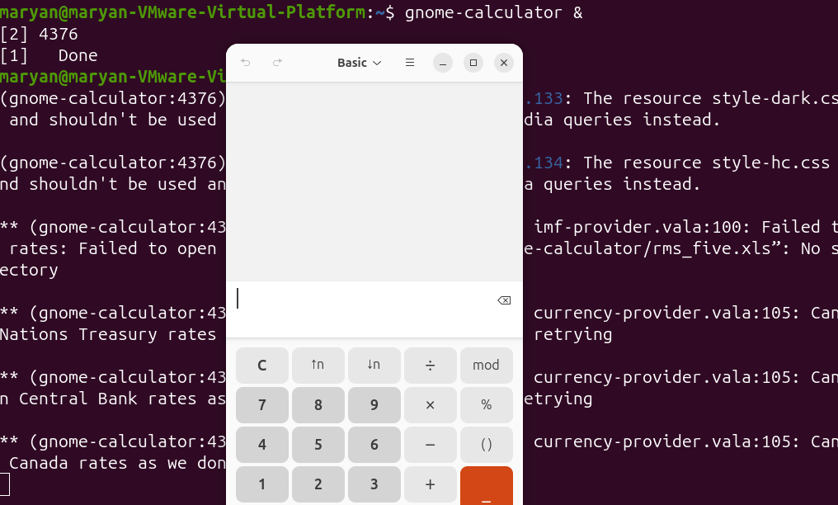
21.ctrl + c : it interrubts the currently running command
22.ctrl + z: it pauses the process
23.jobs
Explanation:
The jobs command displays background and stopped jobs associated with the current shell.
It helps you identify which jobs are running, stopped or waiting.
Example:
jobs
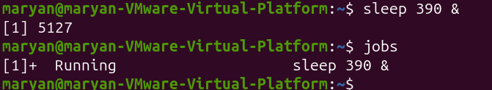
24.jobs -l
Explanation:
The -l option displays the job list together with the PID of each job.
It provides more information than the normal jobs command.
Example:
Jobs -l
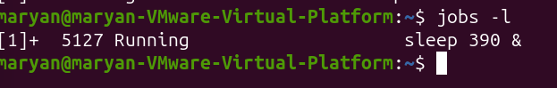
25.bg %N
Explanation:
The bg command resumes a stopped job and allows it to continue running in the background.
%N represents the job number.
Example:
bg %N
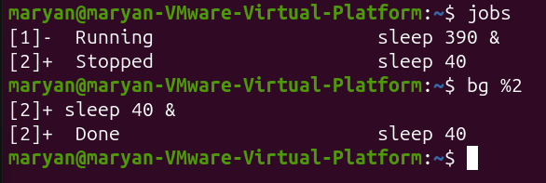

26.fg %N
Explanation:
The fg command brings a background or stopped job into the foreground.
The terminal becomes occupied by that job until it finishes or is stopped.
Example:
fg %N
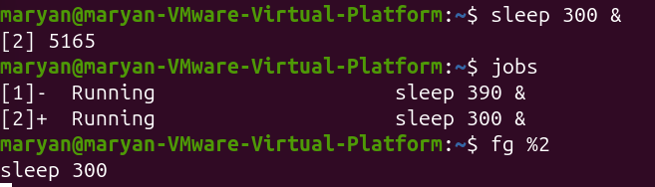

27.fg
Explanation:
When you use fg without specifying a job number, it brings the current job (usually marked with +) into the foreground.
Example:
fg
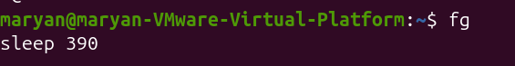
28.kill -l
Explanation:
The kill -l command displays the available signal names and their corresponding numbers.
Signals are messages sent to processes to request actions such as stopping or reloading.
Example:
kill -l: It displays signal names such as SIGTERM, SIGKILL and SIGINT.
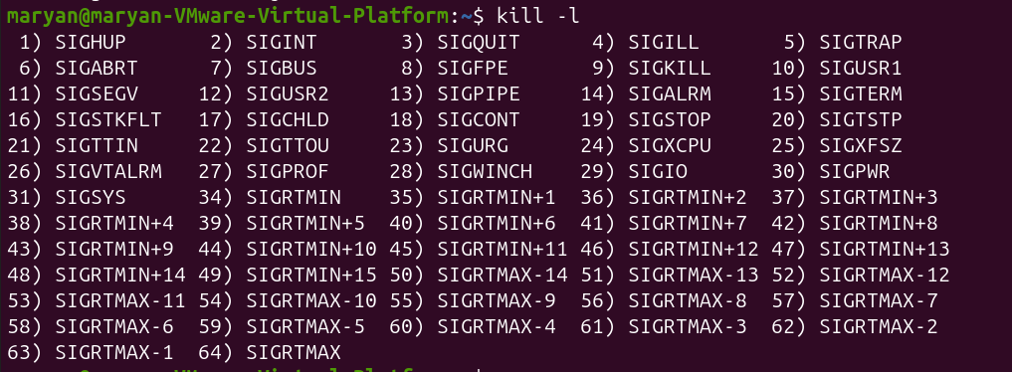

29.kill -l 15
Explanation:
This command displays the name of the signal associated with number 15.
Example:
kill -l 15
30.kill PID
Explanation:
The kill command sends a signal to a process using its PID.
By default, it sends SIGTERM (signal 15), which politely requests the process to finish and exit.
It allows the program to save its work and close files properly.
Example:
kill 5183
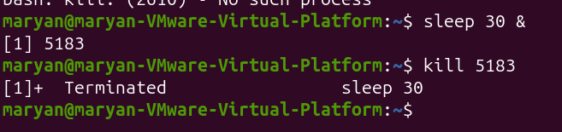
31.kill -TERM PID
Explanation:
This command explicitly sends the SIGTERM signal to the specified process.
It performs the same action as kill PID, but clearly identifies the signal being sent.
Example:
kill -TERM 2612: The process is requested to terminate normally.
32. kill -HUP PID
Explanation:
The -HUP option sends the SIGHUP signal to a process.
Some background services interpret this signal as a request to reload their configuration or reopen their log files.
Example:
sudo kill -HUP 905
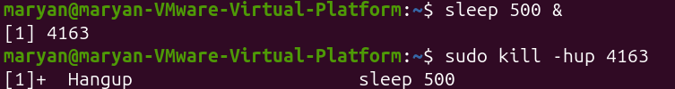
33. kill %N
Explanation:
This command sends the default termination signal to a job using its job number rather than its PID.
It is useful when you know the job number from the jobs command.
Example:
kill %1
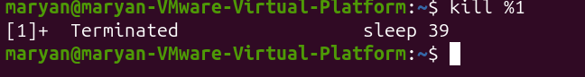
34.ps -p PID
Explanation:
This command checks whether a process with a specific PID is still running.
It is useful after sending a termination signal to confirm whether the process has stopped.
Example:
ps -p 2650 : If only the column headings appear, the process is no longer listed.
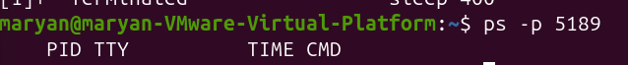

35.kill -9 PID
Explanation:
This command sends SIGKILL (signal 9) to a process.
It forcefully terminates the process immediately without allowing it to save data or perform normal cleanup.
It should only be used as a last resort when normal termination does not work.
Example:
kill -9 5213
36.pgrep -a NAME
Explanation:
The pgrep command searches for running processes using their names.
The -a option displays both the PID and the full command line.
It is useful when you know a program's name but do not know its PID.
Example:
pgrep -a sleep
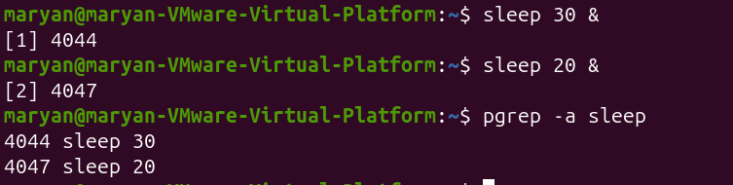
37.pkill -u USER NAME
Explanation:
The pkill command sends a signal to processes matching a specified name or pattern.
The -u option limits the action to processes owned by a particular user.
By default, it sends SIGTERM.
Example:
pkill -u maryan sleep : This sends SIGTERM to sleep processes owned by the maryan user.
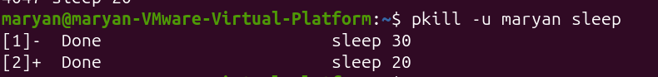
38.killall NAME
Explanation:
The killall command sends a termination signal to processes matching the specified exact process name.
It is useful when you want to stop all processes with the same name without identifying each PID separately.
Example:
killall sleep
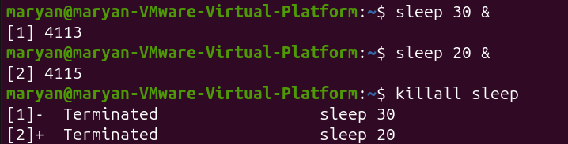
39.nice
Explanation:
The nice command starts a new process with a specified CPU scheduling priority, called niceness.
Niceness values range from -20 to 19.
- -20: Highest scheduling priority.
- 0: Default priority.
- 19: Lowest scheduling priority.
A higher niceness value means the process is more willing to give CPU time to other processes.
Example:
Nice
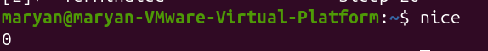
40.nice -n N command
Explanation:
The -n option specifies the niceness value when starting a new process.
It is useful when you want a new process to have lower scheduling priority so that other processes can receive more CPU time.
Example:
nice -n 10 sleep 300 &: This starts a sleep process with niceness 10 in the background.
41.ps -o pid,ni,comm -p PID
Explanation:
This command displays the PID, niceness value and command name of a specific process.
It helps you check the priority assigned to a process.
Example:
ps -o pid,ni,comm -p 3301: NI represents the niceness value.
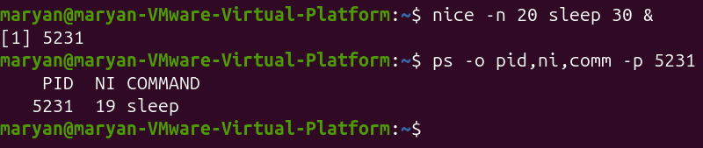
42.renice -n N -p PID
Explanation:
The renice command changes the niceness value of a process that is already running.
Unlike nice, which sets priority when starting a new process, renice modifies the priority of an existing process.
Example:
renice -n 15 -p 3301: This changes process 3301's niceness to 15.
43.sudo renice
Explanation:
The sudo command allows an authorized user to execute a command with administrator privileges.
When used with renice, it allows the administrator to make the process's niceness lower and give it higher scheduling priority.
Example:
sudo renice -n 5 -p 3301: This changes the process niceness to 5 with administrator privileges.
44.top -p PID
Explanation:
This command opens the top monitoring tool and displays information about one specific process.
It is useful when you want to monitor one process instead of viewing every running process.
Example:
top -p 3301 : You can monitor its CPU, memory and scheduling information.
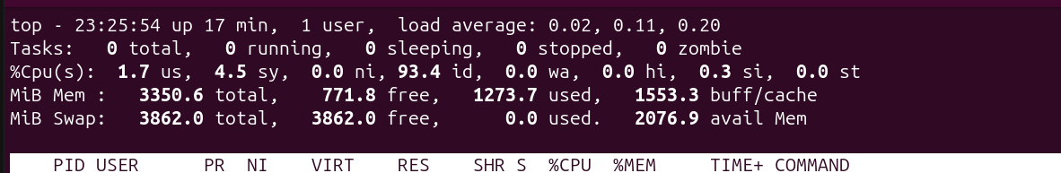
System Information
45. uname
Explanation:
The uname command displays information about the currently running Linux kernel and the machine's hardware architecture.
It helps administrators identify the kernel and system information.
Example:
Uname
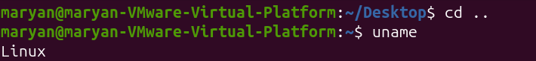
46.uname -r
Explanation:
The -r option displays the kernel release version currently running on the system.
It is useful when checking kernel versions or reporting system problems.
Example:
uname -r
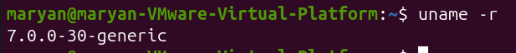
47.uname -m
Explanation:
The -m option displays the machine's hardware architecture.
It helps identify whether the system uses an architecture such as x86_64 or aarch64.
Example:
uname -m
48.uname -n
Explanation:
The -n option displays the network hostname of the computer.
The hostname is the name used to identify the machine on a network.
Example:
uname -n
49.uname -a
Explanation:
The -a option displays all available system information in one line.
It combines information such as the operating system name, hostname, kernel release and hardware architecture.
Example:
uname -a
50.hostnamectl
Explanation:
The hostnamectl command displays information about the computer's hostname, operating system, kernel and virtualization environment.
It helps identify whether the system is running on physical hardware or inside a virtual machine.
Example:
Hostnamectl
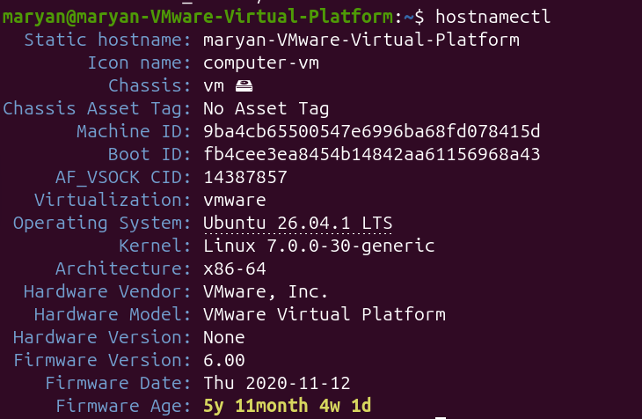
51.hostnamectl hostname
Explanation:
hostnamectl hostname
Explanation:
This command displays only the hostname of the computer.
It is useful when you need the system name without displaying the full system information.
Example:
hostnamectl hostname
52.uptime
Explanation:
The uptime command displays how long the computer has been running since its last boot.
It also shows the current time, number of logged-in users and system load averages.
Example:
uptime
53.uptime -p
Explanation:
The -p option displays the system's running time in a human-readable format.
Instead of displaying technical time information, it uses words such as hours and minutes.
Example:
uptime -p
54.uptime -s
Explanation:
The -s option displays the exact date and time when the computer was last started.
It is useful when investigating unexpected restarts or checking the last boot time.
Example:
uptime -s
55.nproc
Explanation:
The nproc command displays the number of processing units available to the current process.
It helps determine how many CPUs are available for running programs.
Example:
nproc
56.free
Explanation:
The free command displays information about RAM and swap memory.
It shows the total memory, used memory, free memory, shared memory and available memory.
Example:
free
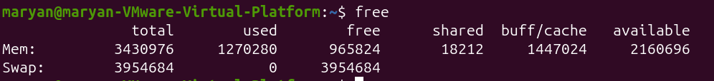
57.free -h
Explanation:
The -h option means human-readable format.
It displays memory sizes using understandable units such as MiB and GiB instead of large numbers of kilobytes.
Example:
free -h
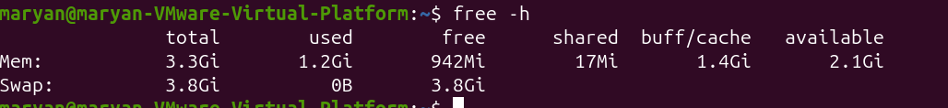
58.free -m
Explanation:
The -m option displays memory information in mebibytes (MiB).
It is useful when you want to read memory usage in a smaller unit.
Example:
free -m
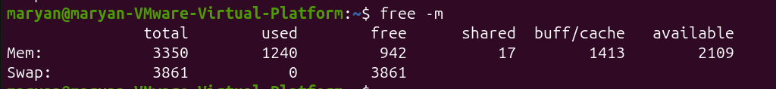
59.free -h -s 2
Explanation:
This command displays memory information in human-readable format and refreshes the results every two seconds.
It helps monitor memory usage continuously while opening or running applications.
Example:
free -h -s 2
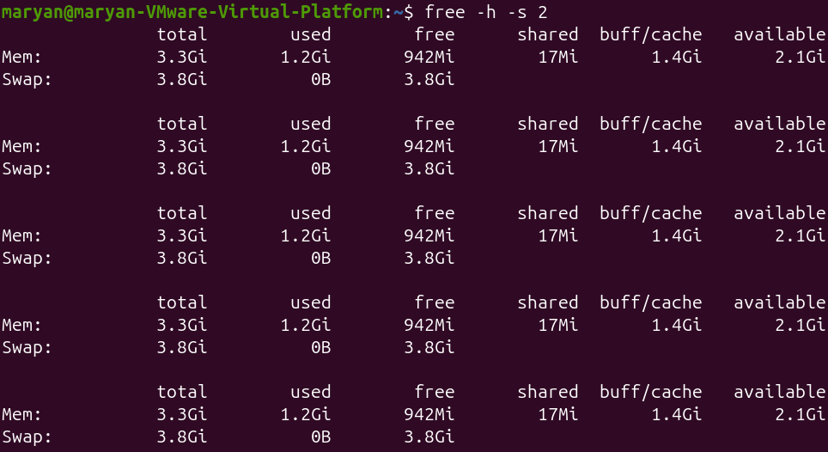
60.lscpu
Explanation:
The lscpu command displays detailed information about the CPU architecture and processor.
It provides information such as CPU count, processor model, architecture and virtualization details.
Example:
Lscpu: Useful when checking the CPU information of your Ubuntu VM.
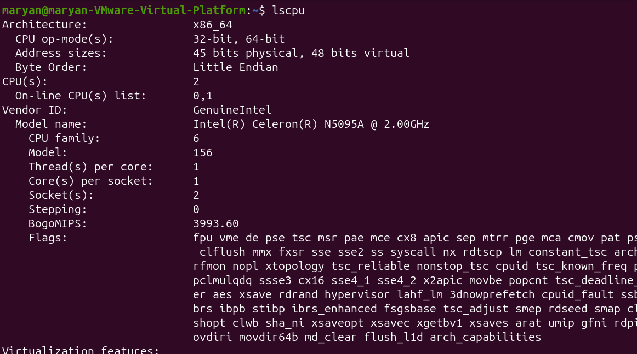
61.lscpu | less
Explanation:
This command displays CPU information page by page using less.
It is useful when the CPU information is too long to fit on one screen.
Example:
lscpu | less
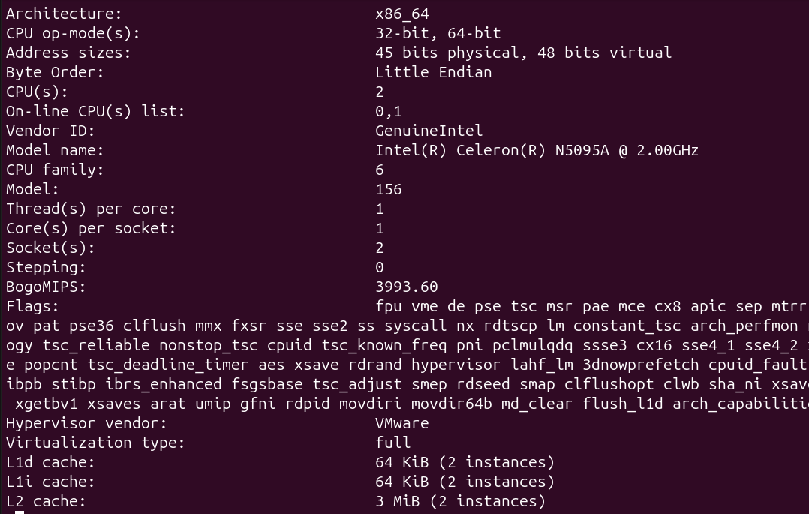
62.lsblk
Explanation:
The lsblk command lists block devices detected by the Linux kernel.
Block devices include hard disks, SSDs, partitions and CD-ROM devices.
It helps you understand which storage devices are connected to the computer.
Example:
lsblk
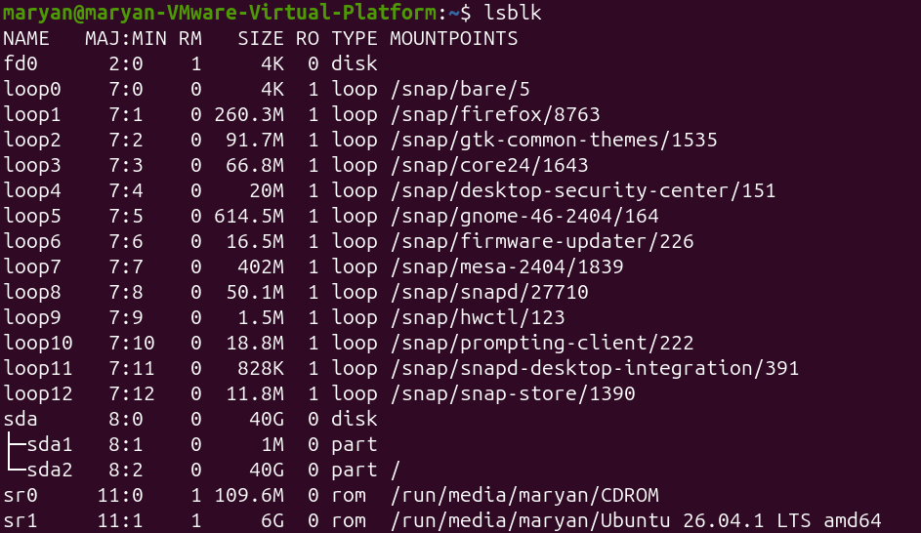
63.lsblk -e 7
Explanation:
The -e 7 option excludes devices with major device number 7, which are loop devices.
Loop devices are commonly associated with Snap packages.
Example:
lsblk -e 7
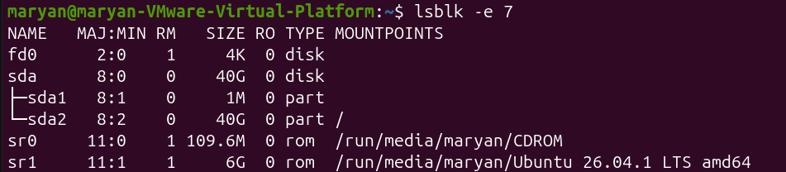
64.lsblk -e 7 -d -o NAME,SIZE,MODEL
Explanation:
This command displays only whole storage devices and excludes loop devices.
- -e 7: Excludes loop devices.
- -d: Displays whole disks only.
- -o: Selects the columns to display.
Example:
lsblk -e 7 -d -o NAME,SIZE,MODEL
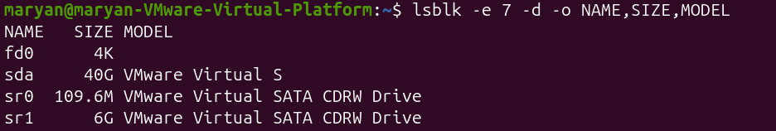
65.ls /proc
Explanation:
The ls command lists files and directories.
When used with /proc, it displays information provided by the Linux kernel about running processes and system information.
/proc is a virtual filesystem generated by the kernel, not a normal folder stored on the disk.
Example:
ls /proc
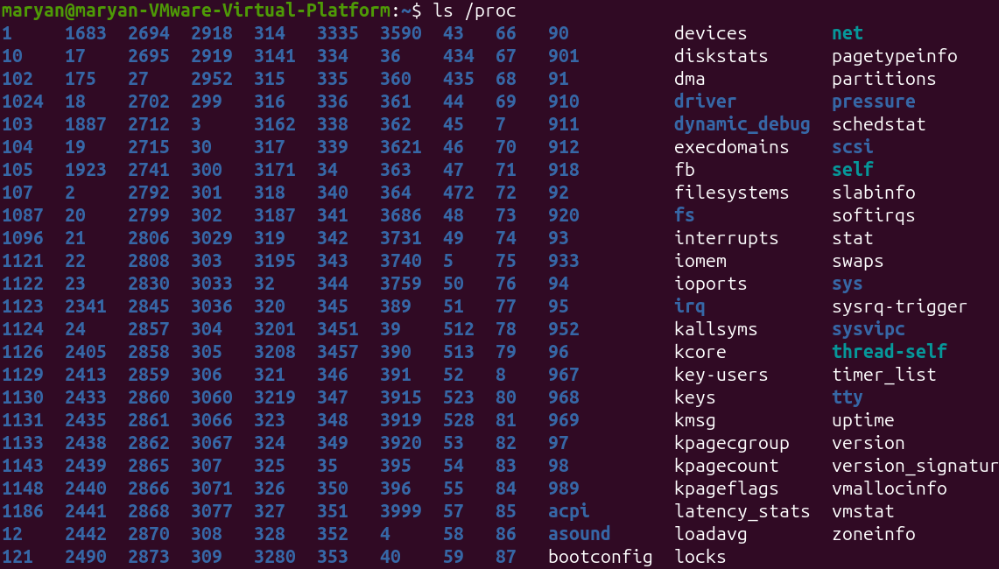
66.ls -l /proc/meminfo
Explanation:
This command displays detailed file information about /proc/meminfo.
The -l option provides a long listing, showing permissions, owner, size and modification information.
Example:
ls -l /proc/meminfo: Although the file may show a size of zero, it contains memory information generated by the kernel when read.
67..cat /proc/uptime
Explanation:
The cat command displays the contents of a file.
When used with /proc/uptime, it displays how many seconds the system has been running since boot and the accumulated idle time.
Example:
cat /proc/uptime
68.cat /proc/loadavg
Explanation:
This command displays the system load averages directly from the /proc filesystem.
It shows the average number of processes running or waiting over 1, 5 and 15 minutes.
Example:
cat /proc/loadavg
69.ls /proc/$$
Explanation:
This command lists the files and directories associated with the current shell process.
The $$ variable automatically represents the PID of the current shell.
Example:
ls /proc/$$:You can see files such as status, comm, cmdline and exe.
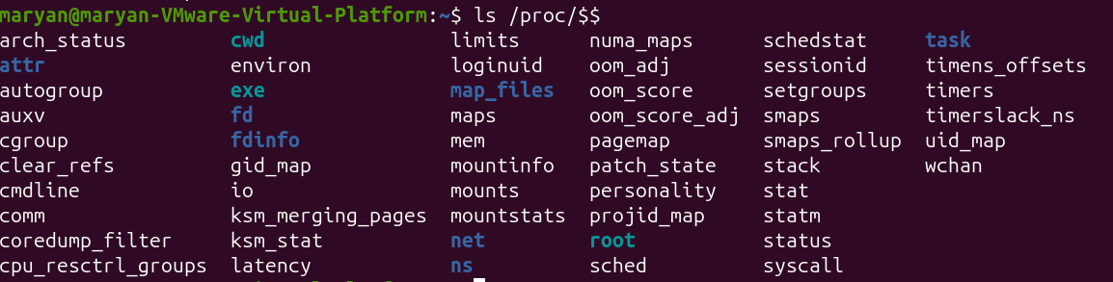
70.head -n 7 /proc/$$/status
Explanation:
The head command displays the beginning of a file.
The -n 7 option displays the first seven lines.
Here it displays information about the current shell process, including its name, state, PID and PPID.
Example:
head -n 7 /proc/$$/status
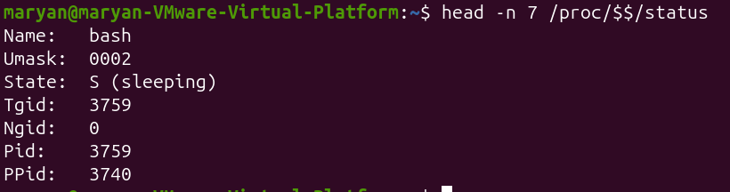
71.cat /proc/1/comm
Explanation:
This command displays the short name of process number 1.
On Ubuntu systems using systemd, PID 1 is normally the systemd process.
Example:
cat /proc/1/comm
72.grep -m 1 "model name" /proc/cpuinfo
Explanation:
The grep command searches for specific text inside a file.
The -m 1 option stops after finding the first matching line.
This example searches for the CPU model name inside /proc/cpuinfo.
Example:
grep -m 1 "model name" /proc/cpuinfo: It displays the processor model.
73.grep -c ^processor /proc/cpuinfo
Explanation:
The -c option counts the number of matching lines.
The ^processor pattern searches for lines beginning with the word processor.
This command helps identify the number of processor entries in /proc/cpuinfo.
Example:
grep -c ^processor /proc/cpuinfo
74.head -n 3 /proc/meminfo
Explanation:
This command displays the first three lines of /proc/meminfo.
The file contains detailed information about the system's memory usage.
Example:
head -n 3 /proc/meminfo
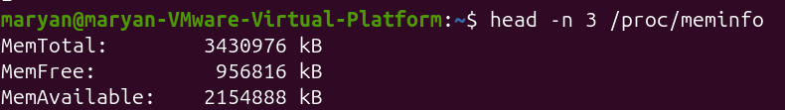
75.ls /sys
Explanation:
The ls command lists the main categories inside /sys.
The /sys filesystem provides information about hardware devices, drivers and kernel objects.
Example:
ls /sys
76.ls /sys/block
Explanation:
This command displays block devices detected by the Linux kernel.
It helps identify disks and other block storage devices.
Example:
ls /sys/block
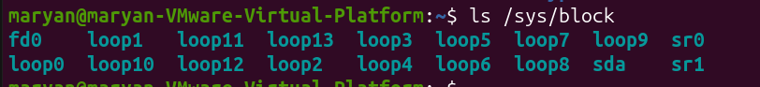
77.ls /sys/class/net
Explanation:
This command lists the network interfaces available on the computer.
A network interface is a device or virtual interface used for network communication.
Example:
ls /sys/class/net
78.cat /sys/class/net/enp0s3/address
Explanation:
This command displays the hardware address (MAC address) of the specified network interface.
It is useful when identifying a network card.
Example:
cat /sys/class/net/ens33/address
4.4 Services with systemd
79.ps -p 1 -o pid,comm
Explanation:
This command displays the PID and command name of process number 1.
It helps confirm that systemd is the first process running on an Ubuntu system.
Example:
ps -p 1 -o pid,comm
80.systemctl cat cron
Explanation:
The systemctl cat command displays the unit file associated with a service.
A unit file describes how systemd manages and starts a service.
Example:
systemctl cat cron: It displays the configuration of the cron service.
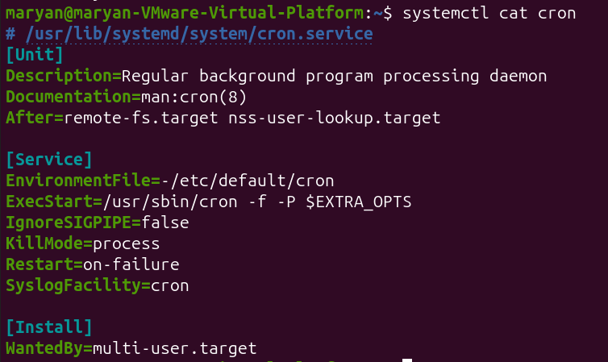
81.systemctl status cron
Explanation:
The systemctl status command displays the current status and information about a service.
It tells you whether the service is running, stopped or failed, and whether it is enabled at boot.
Example:
systemctl status cron
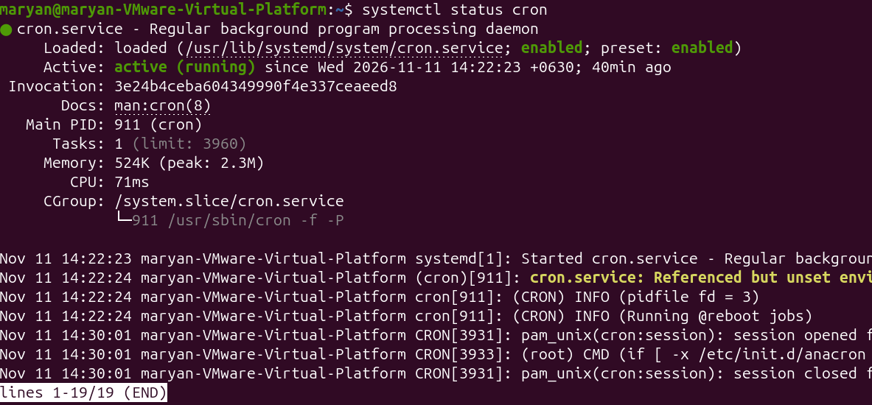
82.systemctl is-active cron
Explanation:
This command checks whether a particular service is currently active.
It provides a simple answer without displaying the full status report.
Example:
systemctl is-active cron
83.systemctl is-enabled cron
Explanation:
This command checks whether a service is configured to start automatically when the computer boots.
It is important to understand that enabled and active are different.
Example:
systemctl is-enabled cron
84.sudo systemctl stop cron
Explanation:
The stop action stops a currently running service.
The sudo command is used because stopping system services requires administrator privileges.
Example:
sudo systemctl stop cron: This stops the cron service immediately.
85.sudo systemctl start cron
Explanation:
The start action starts a service that is currently stopped.
It is useful when a service is inactive and you want to run it again.
Example:
sudo systemctl start cron
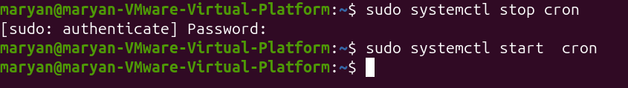
86.sudo systemctl restart cron
Explanation:
The restart action stops the service and starts it again.
It is useful when you want to restart a service or apply changes that require restarting.
Example:
sudo systemctl restart cron: The service receives a new process when restarted.
87.systemctl show -p MainPID cron
Explanation:
The systemctl show command displays selected properties of a systemd service.
The -p MainPID option requests only the main process ID.
Example:
systemctl show -p MainPID cron
88.sudo systemctl reload ssh
Explanation:
The reload action asks a running service to read its configuration files again without completely stopping the service.
It is useful when a service supports configuration reloading and you want to avoid interrupting existing connections.
Example:
sudo systemctl reload ssh: It may return an error stating that reload is not applicable.
89. sudo systemctl reload cron
Explanation:
This command attempts to reload the cron service configuration without stopping it.
However, the slide explains that cron does not support the reload action.
Example:
sudo systemctl reload cron
90.sudo systemctl reload-or-restart cron
Explanation:
This command first attempts to reload the service.
If the service does not support reload, systemd restarts it instead.
Example:
sudo systemctl reload-or-restart cron
91.sudo systemctl enable cron
Explanation:
The enable action configures a service to start automatically when the system boots.
It does not necessarily start the service immediately.
Example:
sudo systemctl enable cron
92.sudo systemctl disable cron
Explanation:
The disable action prevents a service from starting automatically during future system boots.
It does not automatically stop a service that is already running.
Example:
sudo systemctl disable cron
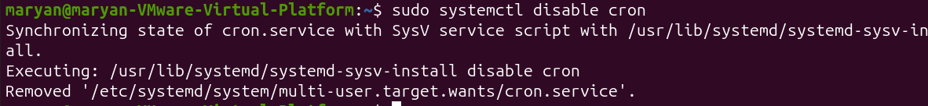
93.sudo systemctl enable --now cron
Explanation:
This command enables the service for automatic startup and starts it immediately.
The --now option combines the boot setting with an immediate action.
Example:
sudo systemctl enable --now cron
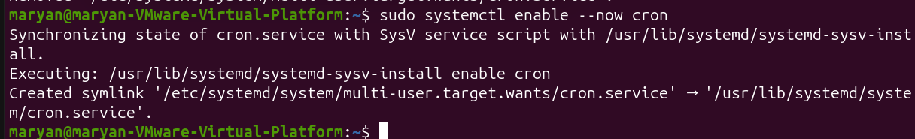
94.systemctl list-units --type=service --state=running
Explanation:
This command lists services currently running under systemd.
The options filter the results so that only running services are displayed.
Example:
systemctl list-units --type=service --state=running
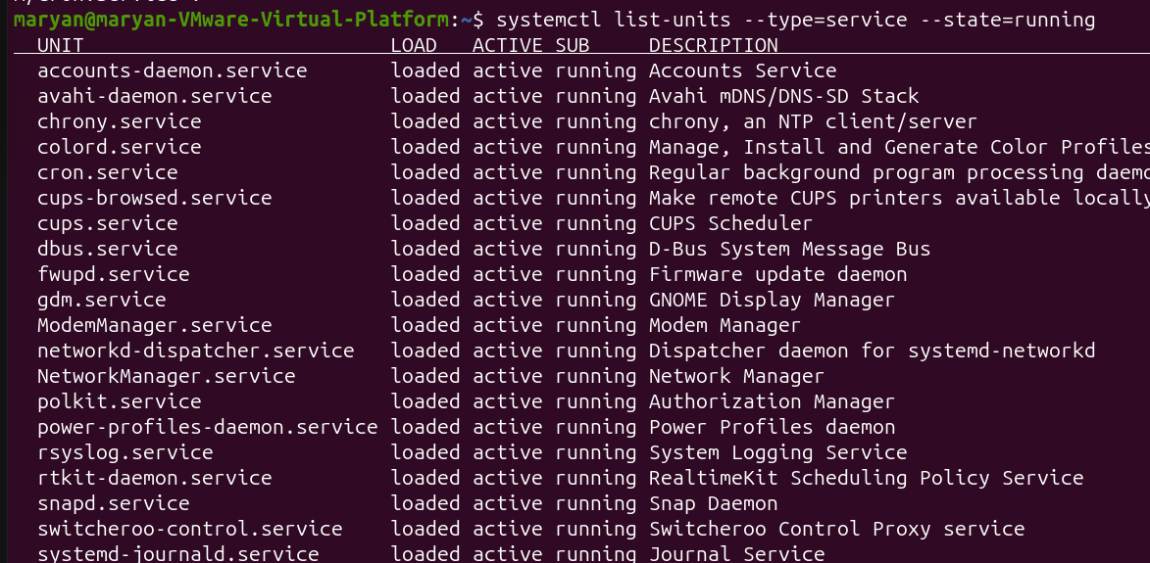
95.Systemctl list-units --type=service --state=failed
Explanation:
This command displays service units that have failed.
It is useful when troubleshooting system problems because it helps identify services that did not start or operate correctly.
Example:
systemctl list-units --type=service --state=failed
4.5 Logs, Boot and Troubleshooting
96.journalctl
Explanation:
The journalctl command is used to read system logs collected by systemd.
System logs contain information about system activities, services, errors and events.
It is useful when troubleshooting problems because it helps identify what happened before a failure.
Example:
Journalctl
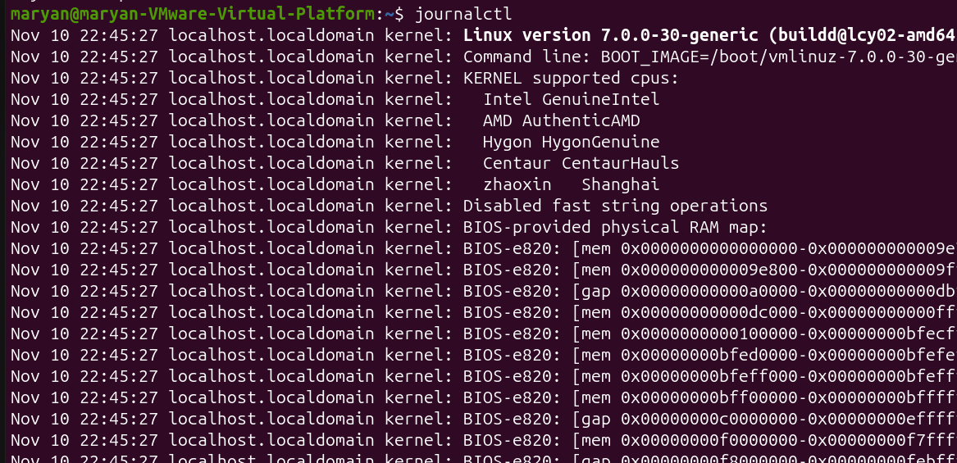
97.journalctl -n 3
Explanation:
The -n option displays a specified number of the most recent journal entries.
It is useful when you only want to see the latest system messages.
Example:
journalctl -n 3
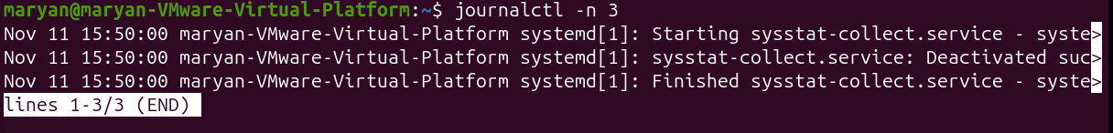
98.journalctl -b
Explanation:
The -b option displays journal messages from the current boot session.
It helps administrators investigate problems that happened after the computer was last started.
Example:
journalctl -b
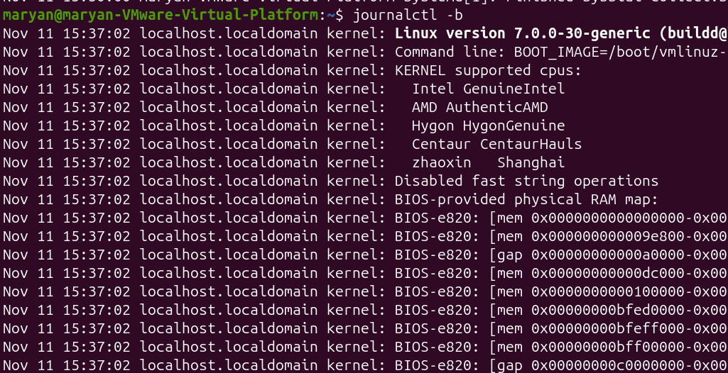
99.journalctl -b -p err
Explanation:
This command displays error-level messages and more serious messages from the current boot session.
It helps you focus on problems instead of reading every normal system message.
Example:
journalctl -b -p err
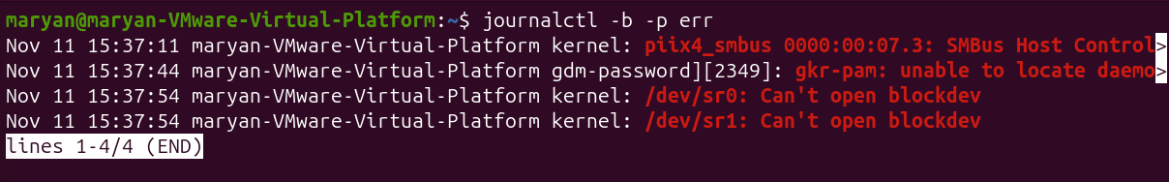
100.journalctl -xe
Explanation:
This command displays recent journal messages and adds explanatory information where available.
- -x: Adds explanatory text.
- -e: Jumps to the end of the journal.
It is useful when investigating a recent error.
Example:
journalctl -xe
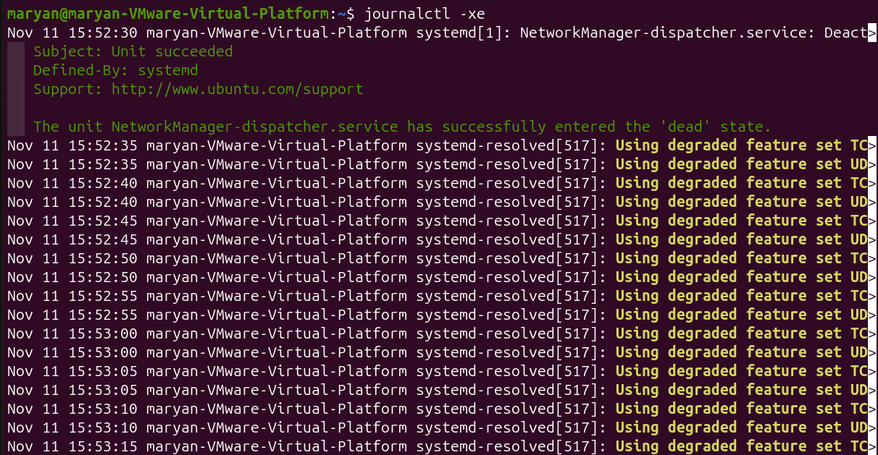
101.journalctl -f
Explanation:
The -f option follows the journal and displays new log entries as they are created.
It works similarly to watching a live stream of system events.
Example:
journalctl -f
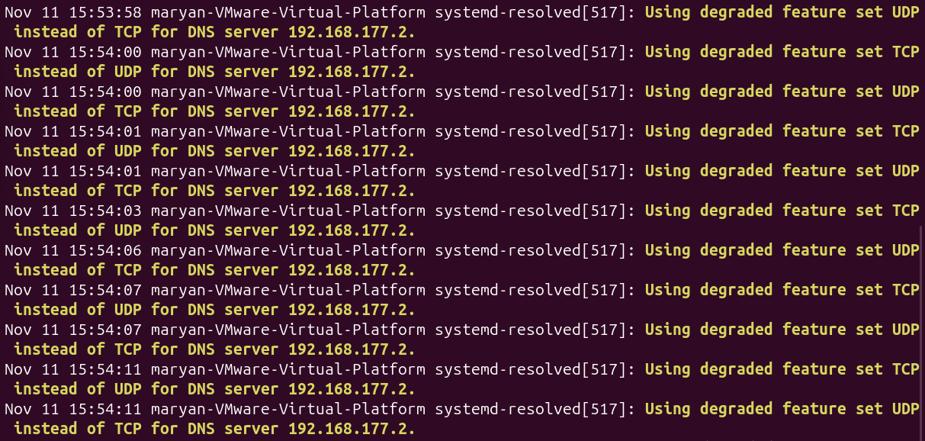
102.logger "week 8 test from student"
Explanation:
The logger command writes a test message into the system logging system.
It is useful for testing whether new messages appear in the journal.
Example:
logger "week 8 test from student"
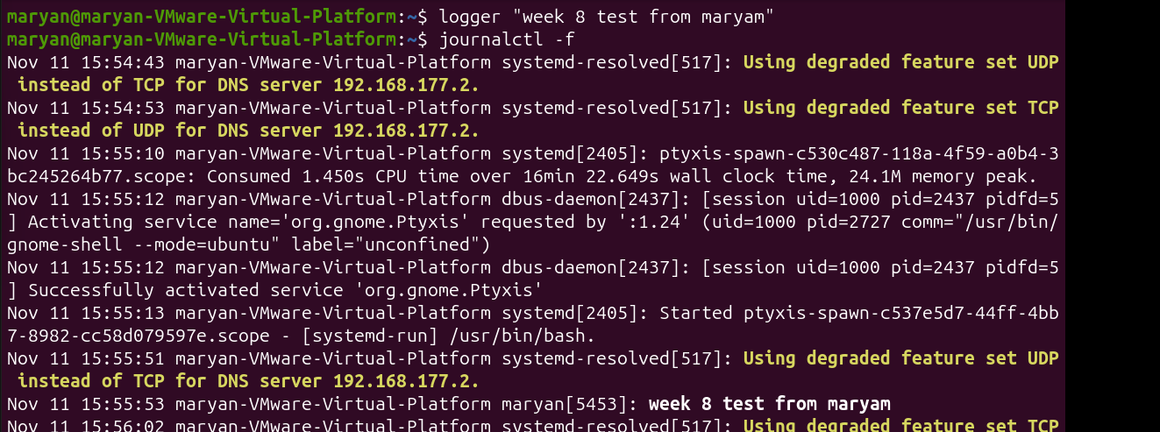
103.journalctl -u cron -f
Explanation:
This command follows new log messages generated by one specific service.
- -u cron: Selects the cron service.
- -f: Displays new messages continuously.
Example:
journalctl -u cron -f
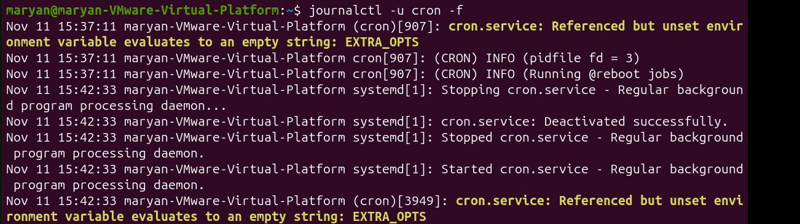
104.ls /var/log
Explanation:
The /var/log directory stores traditional Linux system log files.
The ls command lists the log files and directories available in that location.
Example:
ls /var/log
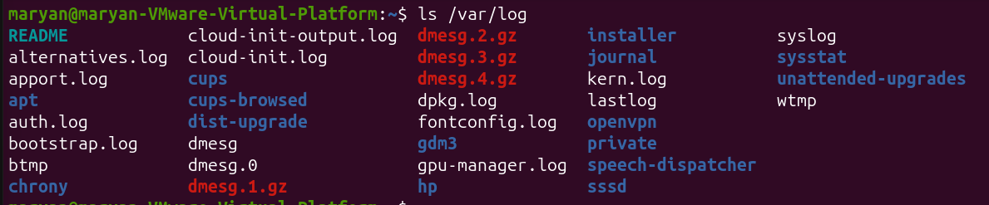
105.less /var/log/syslog
Explanation:
This command opens the system log file using the less pager.
It allows you to read the log page by page without modifying the file.
Example:
less /var/log/syslog
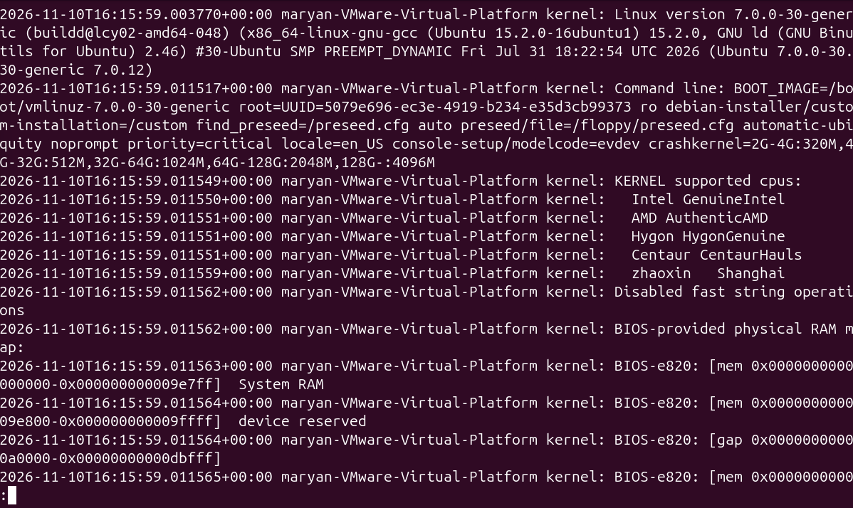
106.tail -n 3 /var/log/kern.log
Explanation:
The tail command displays the end of a file.
The -n 3 option displays only the last three lines.
This is useful when checking the most recent kernel messages.
Example:
tail -n 3 /var/log/kern.log
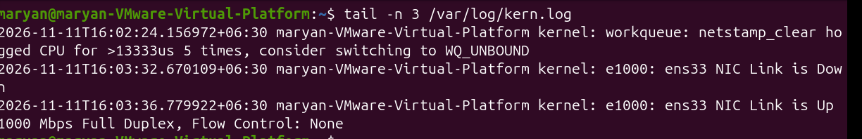
107.tail -f /var/log/syslog
Explanation:
The -f option follows a log file and continuously displays new lines as they are added.
It is useful for monitoring system activity in real time.
Example:
tail -f /var/log/syslog
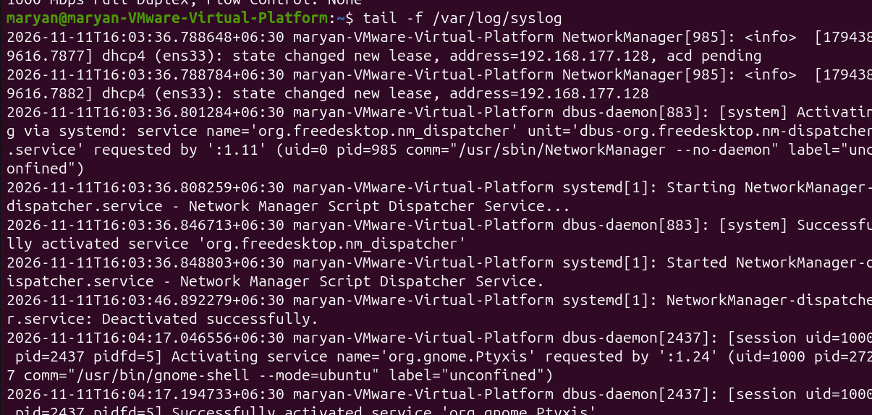
108.grep sudo /var/log/auth.log
Explanation:
The grep command searches for lines containing the word sudo in the authentication log.
It is useful when checking administrative activities and commands executed using sudo.
Example:
grep sudo /var/log/auth.log
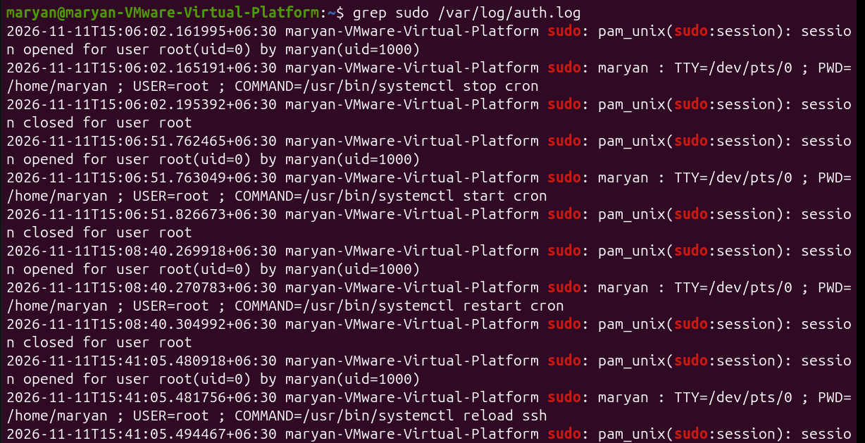
109.grep sudo /var/log/auth.log | tail -n 1
Explanation:
This command searches the authentication log for sudo-related entries and displays only the latest matching line.
- grep sudo: Finds lines containing sudo.
- tail -n 1: Displays the last matching line.
Example:
grep sudo /var/log/auth.log | tail -n 1
110.journalctl _COMM=sudo -n 1
Explanation:
This command displays the most recent journal entry generated by a process whose command name is sudo.
- _COMM=sudo: Filters messages associated with the sudo command.
- -n 1: Displays one recent entry.
Example:
journalctl _COMM=sudo -n 1
111.last -n 2
Explanation:
The last command displays information about previous user login sessions and system reboots.
The -n 2 option limits the output to the latest two records.
Example:
last -n 2
112.dmesg
Explanation:
The dmesg command displays messages generated by the Linux kernel.
These messages contain information about hardware detection, drivers, devices and system startup.
It is useful when troubleshooting hardware or device-related problems.
Example:
dmesg
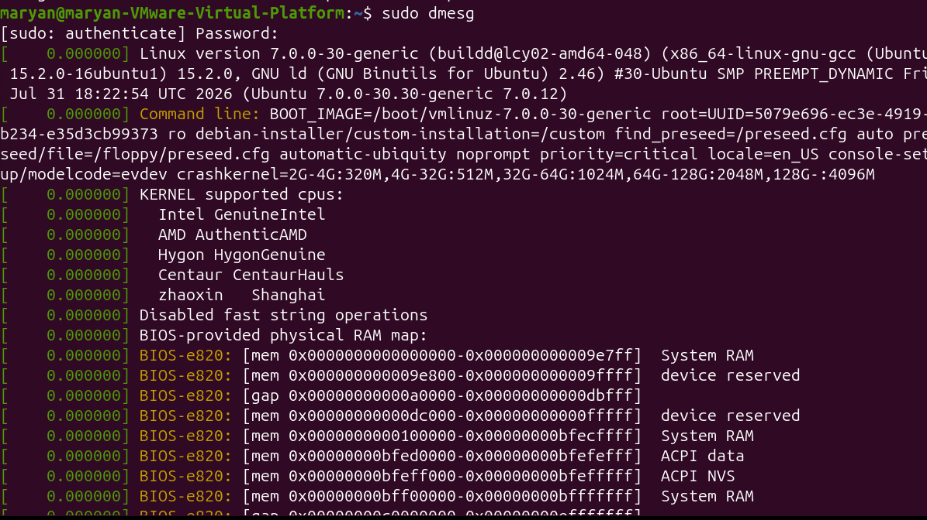
113.sudo dmesg -T | tail -n 2
Explanation:
This command displays the latest two kernel messages with readable date and time information.
- sudo: Runs with administrator privileges.
- dmesg: Displays kernel messages.
- -T: Converts timestamps into readable clock times.
- tail -n 2: Shows the final two messages.
Example:
sudo dmesg -T | tail -n 2
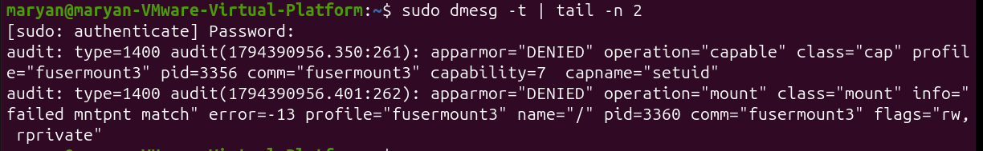
114.sudo dmesg | less
Explanation:
This command displays kernel messages page by page.
It is useful when you want to inspect a large amount of kernel information without scrolling through everything at once.
Example:
sudo dmesg | less
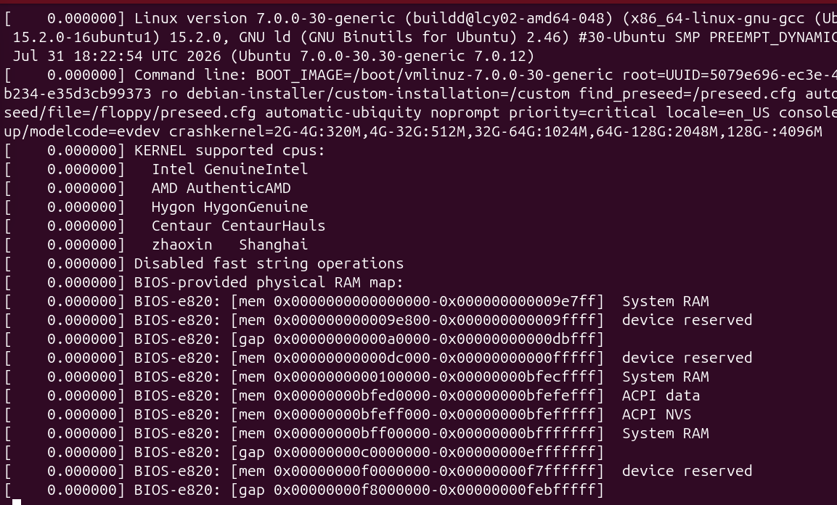
115.journalctl -k -b
Explanation:
This command displays kernel messages collected by the systemd journal during the current boot session.
- -k: Displays kernel messages only.
- -b: Displays messages from the current boot.
Example:
journalctl -k -b
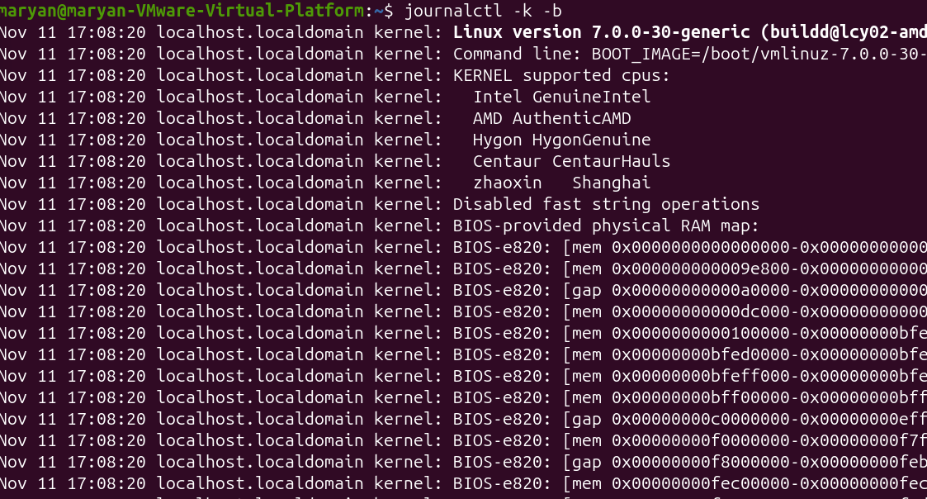
116.sudo shutdown now
Explanation:
The shutdown command safely shuts down the computer.
The now option means the shutdown should happen immediately.
Before switching off, Linux stops services in an orderly manner and performs the necessary shutdown operations.
Example:
sudo shutdown now
117.sudo shutdown -r +5 "Rebooting for the lab"
Explanation:
This command schedules the computer to restart after five minutes.
- -r: Reboot instead of powering off.
- +5: Wait five minutes.
- The quoted text: Provides a shutdown message.
Example:
sudo shutdown -r +5 "Rebooting for the lab"
118.sudo shutdown -c
Explanation:
The -c option cancels a previously scheduled shutdown or reboot.
It is useful when you change your mind about a planned shutdown.
Example:
sudo shutdown -c
119.sudo reboot
Explanation:
The reboot command restarts the computer immediately.
It performs an orderly restart of the operating system.
Example:
sudo reboot
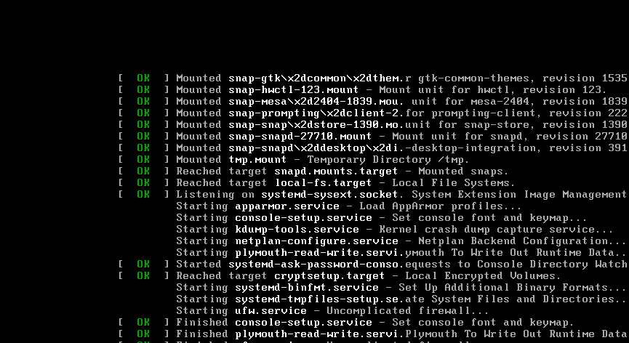
120.sudo poweroff
Explanation:
The poweroff command safely shuts down the operating system and switches off the computer.
It stops running services and performs the required shutdown operations.
Example:
sudo poweroff
121.systemctl status ssh
Explanation:
This command checks the current status of the SSH service.
It helps determine whether SSH is running, enabled or experiencing problems.
Example:
systemctl status ssh

122.journalctl -u ssh
Explanation:
This command displays log messages associated with the SSH service.
It helps identify errors or events that occurred while the SSH service was running.
Example:
journalctl -u ssh
123.journalctl -u ssh -n 30
Explanation:
This command displays the latest 30 journal entries belonging to the SSH service.
It is useful when you want to investigate recent SSH errors without reading the entire log history.
Example:
journalctl -u ssh -n 30
124.ls /etc/ssh
Explanation:
This command lists the files and directories inside /etc/ssh.
This directory contains SSH configuration files.
Example:
ls /etc/ssh
125.sudo sshd -t
Explanation:
The sshd -t command tests the SSH server configuration for syntax errors.
It is useful before restarting the SSH service after changing configuration files.
Example:
sudo sshd -t

